**MINI PROJECT (2020-2021)**

**E-Learning Website**

**Mid-Term Report**



**Institute of Engineering & Technology**

**Submitted by**

**NITISH KUMAR (181500437)**

**Supervised By: -**

**Mrs.Priya agarwal**

**Department of Computer Engineering & Applications**

**Acknowledgment**

I owe to God who continues to look after our hearties of my flaws.

It is my pleasure to have the opportunity to extend our heartiest thank to everybody that has given a valuable contribution towards the successful completion of this project.

First of all, I want to express our deep sense of gratitude to my mentor Mr**s.Priya Agarwal mam** who has encouraged me in the successful completion of this project.

We are highly obliged to my parents who supported me both financially and morally and were the source of great inspiration .

**NITISH KUMAR (181500437)**

**Content**

**Abstract**

1. **Introduction**

* **General Introduction to the topic**
* **Benefits of E-learning**
* **Hardware and Software Requirements**

1. **Features of E-learning**
2. **Objectives**
3. **Implementation Details**
4. **Some Screenshots**
5. **References**

**ABSTRACT**

**The physical classroom learning nowadays is no longer applicable for the current younger generations (Gen Y). In an era known as the society of technology and knowledge, where lifelong learning is a way of life, we are developing a website named as “study point” for goal of finding effective ways of providing new learning material. The project is a Learning based project developed with the help of JavaScript, HTML and CSS .This E-learning website includes computer based learning. This E-learning website provides knowledge to the students about various topics and in an effort to make learning more efficient, equitable and innovative. It provides efficiency and effectiveness in providing education to the students .This website has no registered user, any guest user can take advantage of it.**

**Introduction**

* **General Introduction to the topic**

**E-Learning is the process of using technology to assist learning and tutoring. Enhancement in how the Internet works has allowed websites to deliver a visual and immersive learning experience on a computer or mobile device, perfect for stimulating a student and encouraging learning.**

**E-Learning exploits interactive technologies and communication systems to improve the learning experience. It has the potential to transform the way we teach and learn across the board. ... It can enable every learner to achieve his or her potential, and help to build an educational workforce empowered to change.**

**Benefits of E- Learning Website**

* Added Flexibility and Self-Paced Learning. ...
* Better Time Management. ...
* Demonstrated Self-Motivation. ...
* Improved Virtual Communication and Collaboration. ...
* A Broader, Global Perspective. ...
* Refined Critical-thinking Skills. ...
* New Technical Skills

**Tool Required:**

* **Hardware:**
* PC with 4GB RAM,500GB HDD
* **Software :**
* Visual Studio code
* Github
* XAMPP7.1.33
* **Technology used** :
* CSS, Java Script,Html,Local Host Server
* **Cloud Service :**
* S3(Simple Storage Service)

**FEATURES OF E-LEARNING**

There are several advantages with delivering your learning requirements in this way, not least the overall costs involved, but also that once developed, the system will be your own and we will transfer all intellectual property rights over to you.

**SCALABLE & EFFICIENT** – E-Learning enables you to quickly create and communicate new policies, training, ideas, and concepts. Online E-Learning sessions are especially easy to keep up-to-date because the updated materials are simply uploaded to a server and can be managed from anywhere using a bespoke admin system created to your specific requirements.

**ACCESSIBILITY & TIME SAVING** – E-Learning materials are accessible at any time from any place, meaning learning can fit around your existing daily schedule and eliminate any travel costs associated with classroom based training.

**TRACKING LEARNING ACTIVITIES** – Using a learning management system (LMS) makes it easy to track the students progress. We know that everyone learns at a different rate which is why we follow a modular approach, allowing modules covering familiar topics to be skipped so that you can concentrate on a less well known subject. Full tracking capabilities are built in to provide comprehensive reports for individuals, classes, subjects and modules.

**EASY REFRESH OF CONTENT** – Content can be refreshed easily though our Content Management System allowing course modules to be updated quickly with different subjects and linked back through the scoring and reporting modules.

**CAPACITY & CONSISTENCY** – Using E-Learning allows educators to achieve a great degree of coverage for their target audience, and it ensures that the message is communicated in a consistent fashion. This results in all learners receiving the same training.

**BENEFITS OF E-LEARNING**

**OBJECTIVE**

* Enhance the quality of learning and teaching.
* Meet the learning style or needs of students.
* Improve the efficiency and effectiveness.
* Improve user accessibility and time flexibility to engage learners in the learning process.
* The skill or behavior to be performed.
* The criteria used to measure performance.
* Observable and measurable to be effective.
* Learning objectives are no different than goal because they serve two main purposes :-

(a) To establish the desired result.

(b) To identify the methodology to be used to get there.

* + It include four distinct component i.e.

(a) Audience

(b) Behavior

(c) Condition

(d) Degree

**Implementation Details Flow chart**

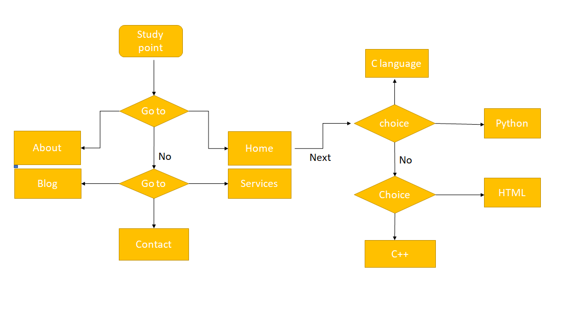

**COURSE CERTIFICATES**

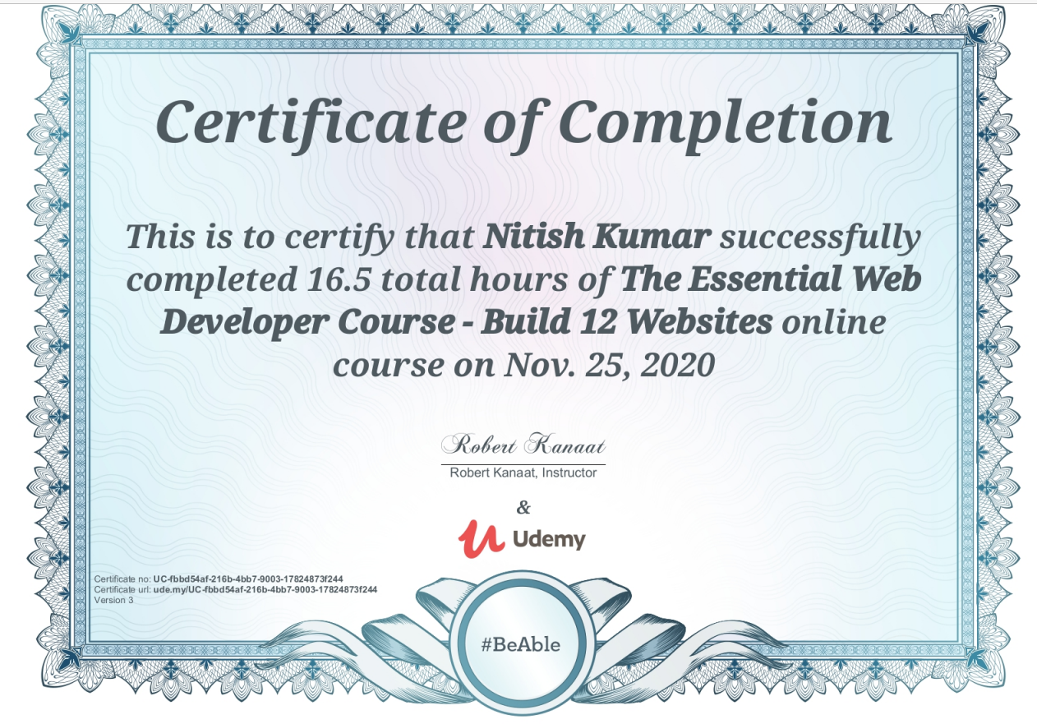

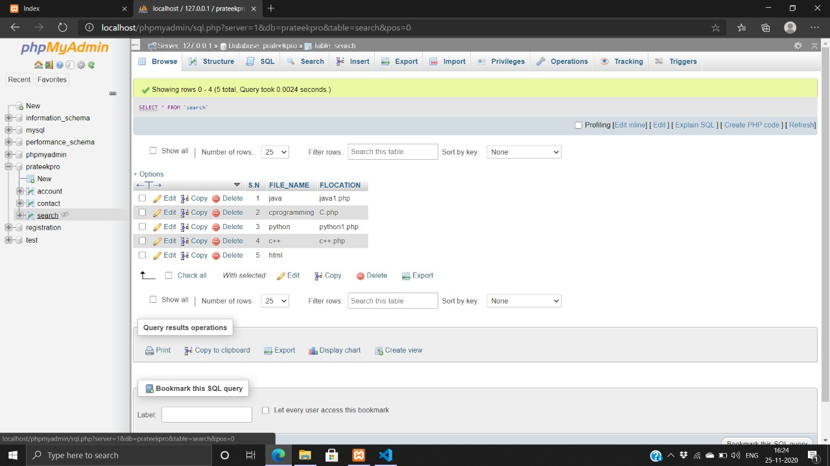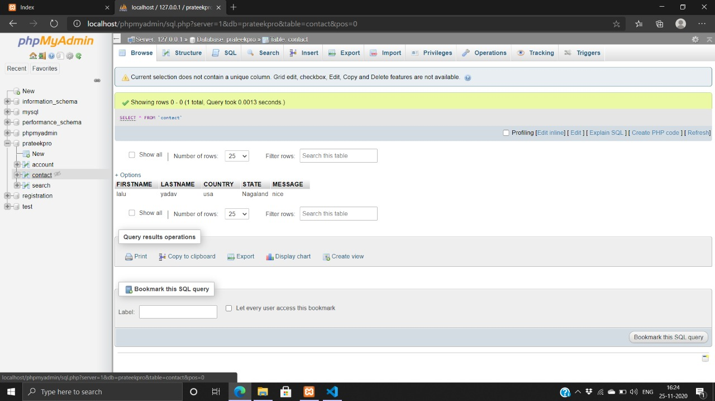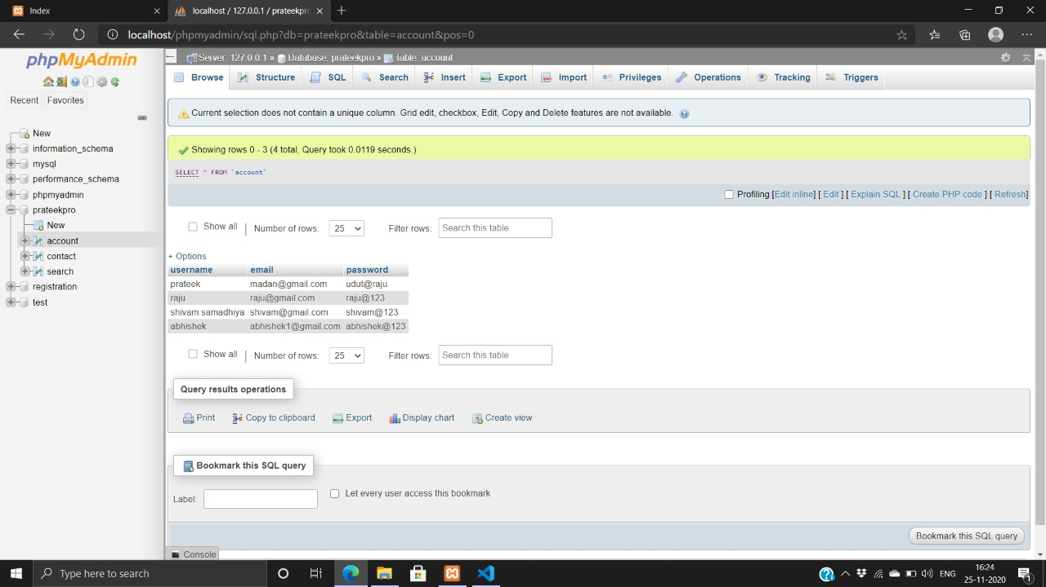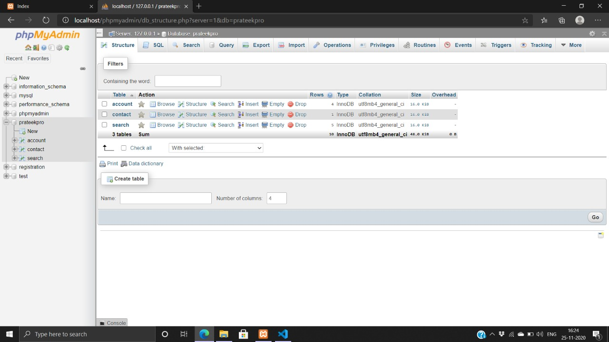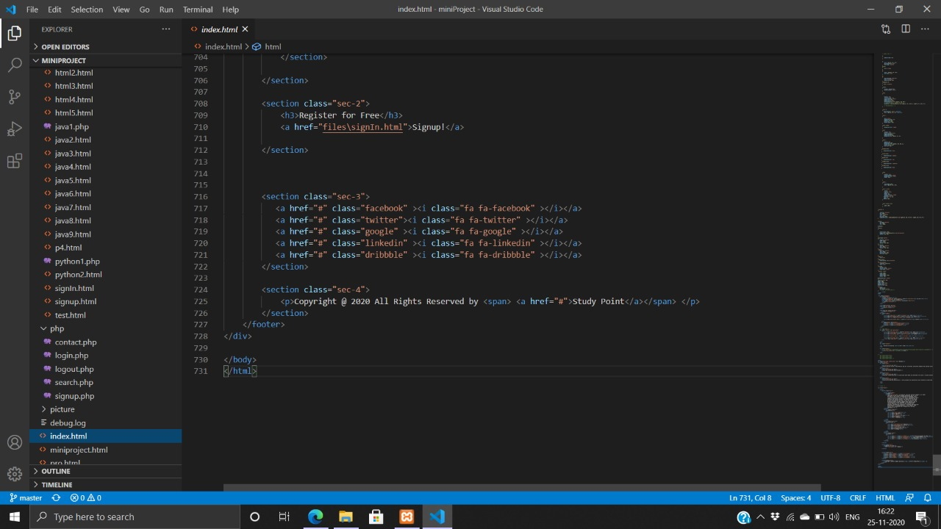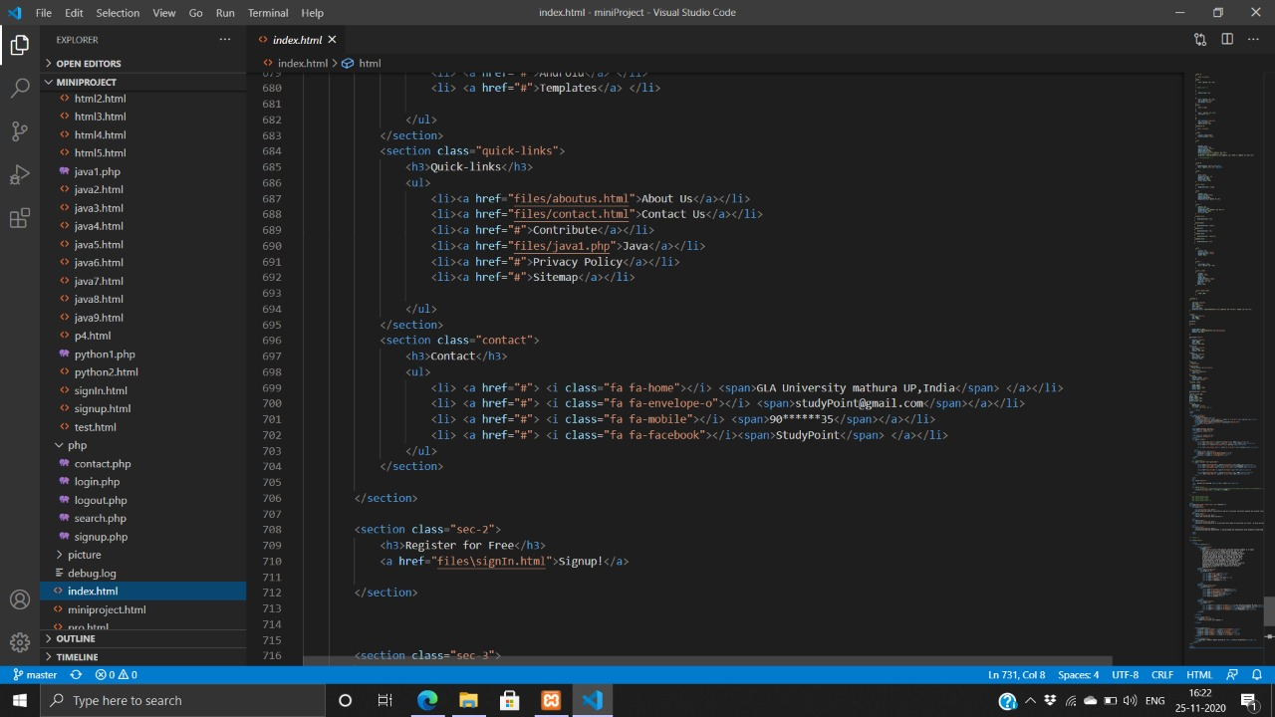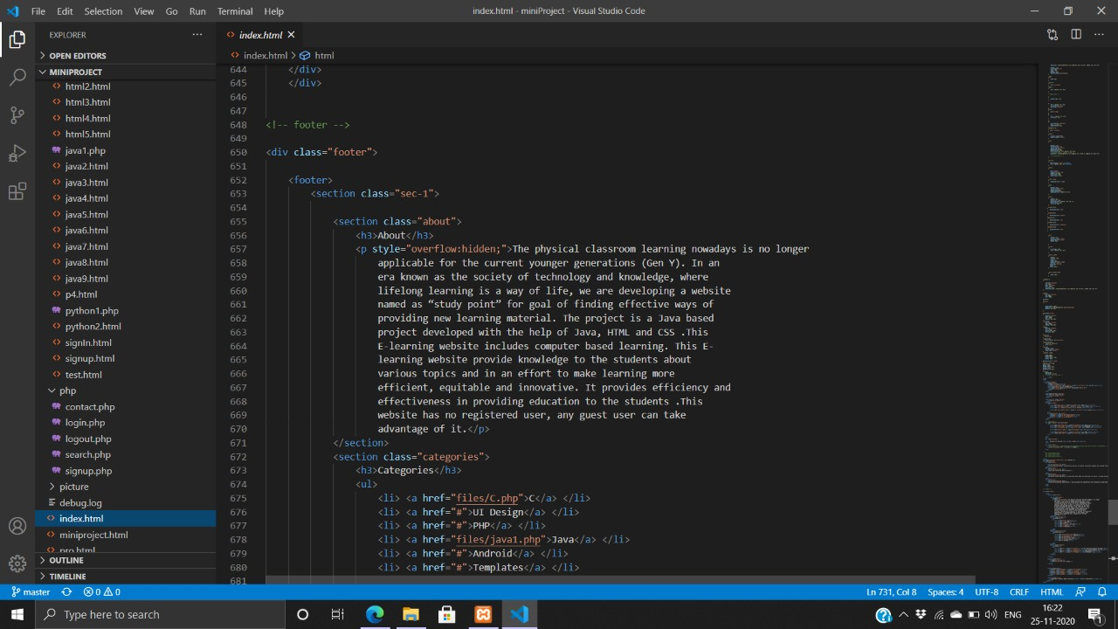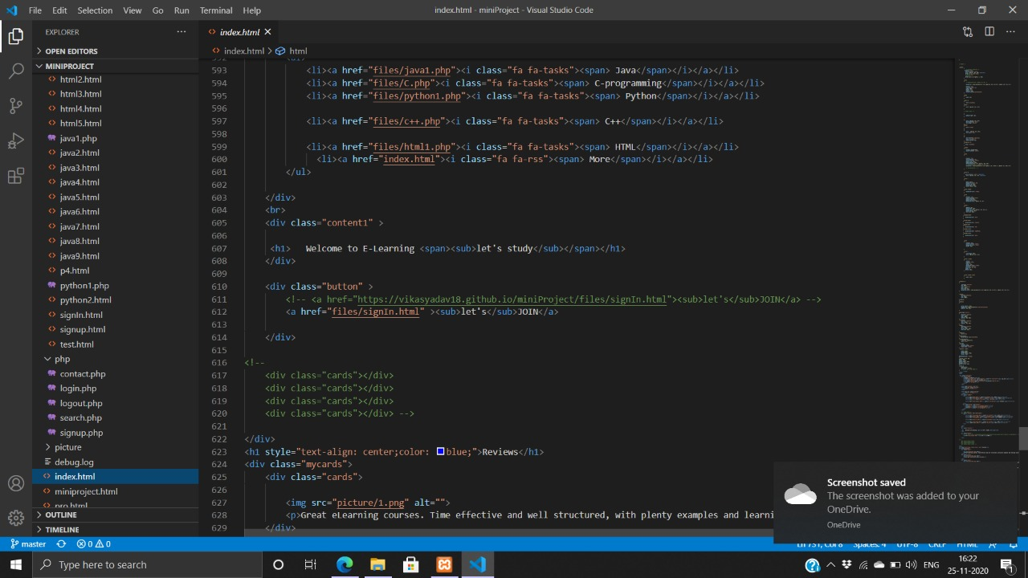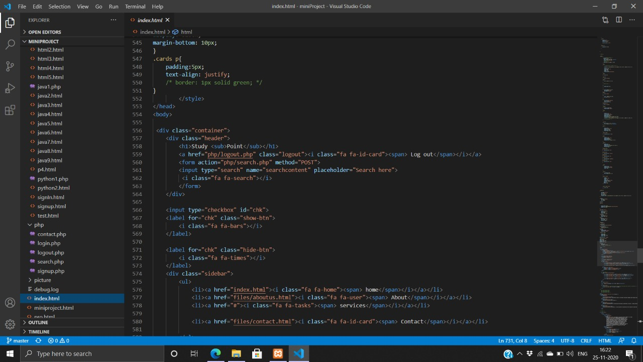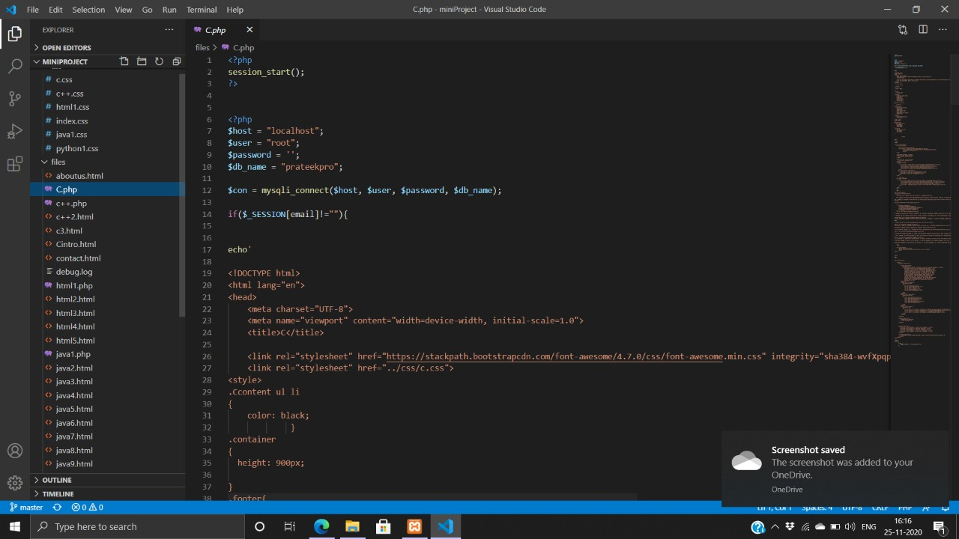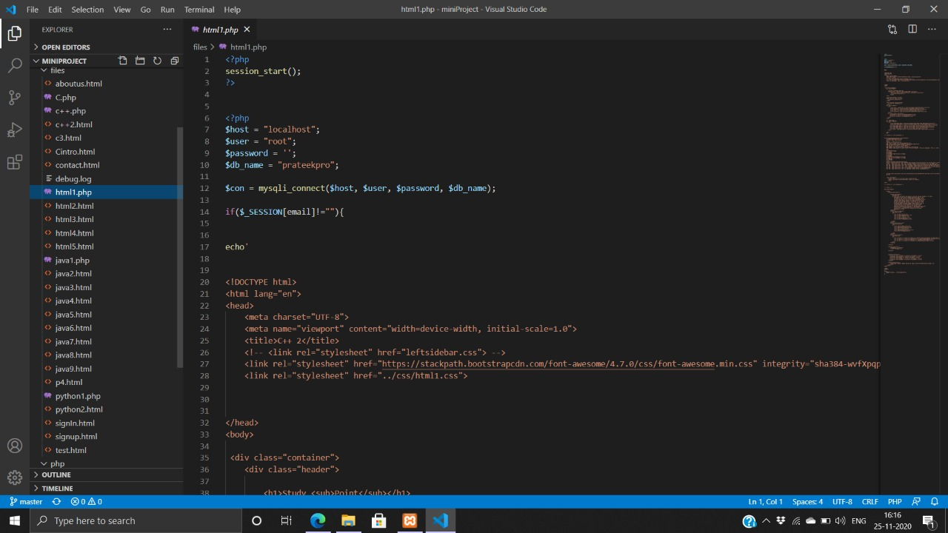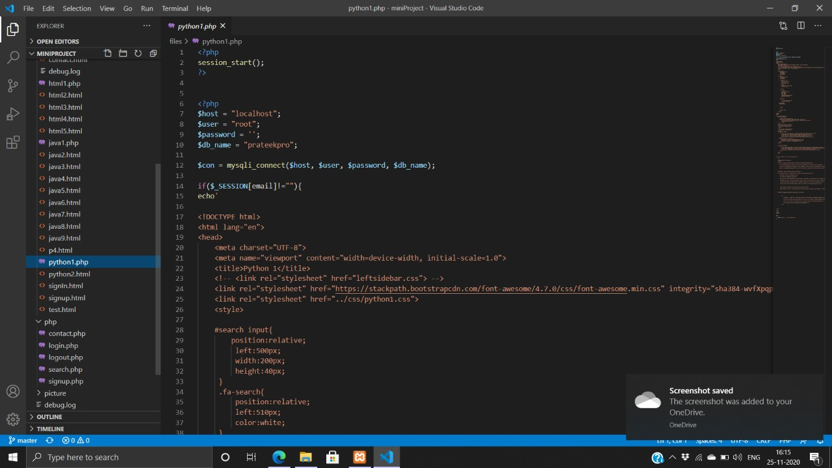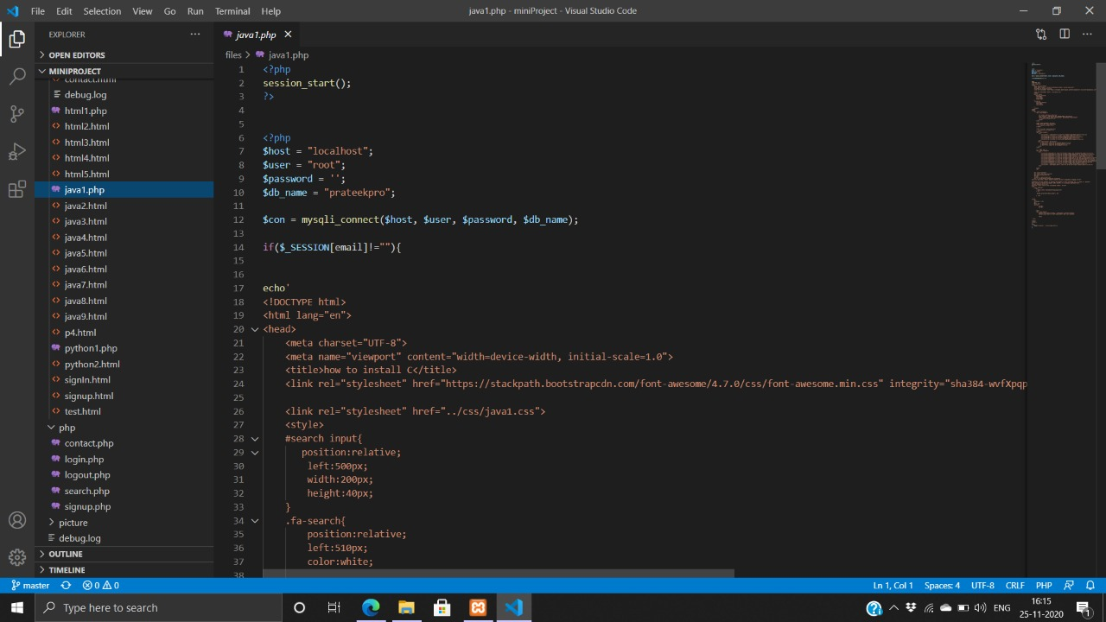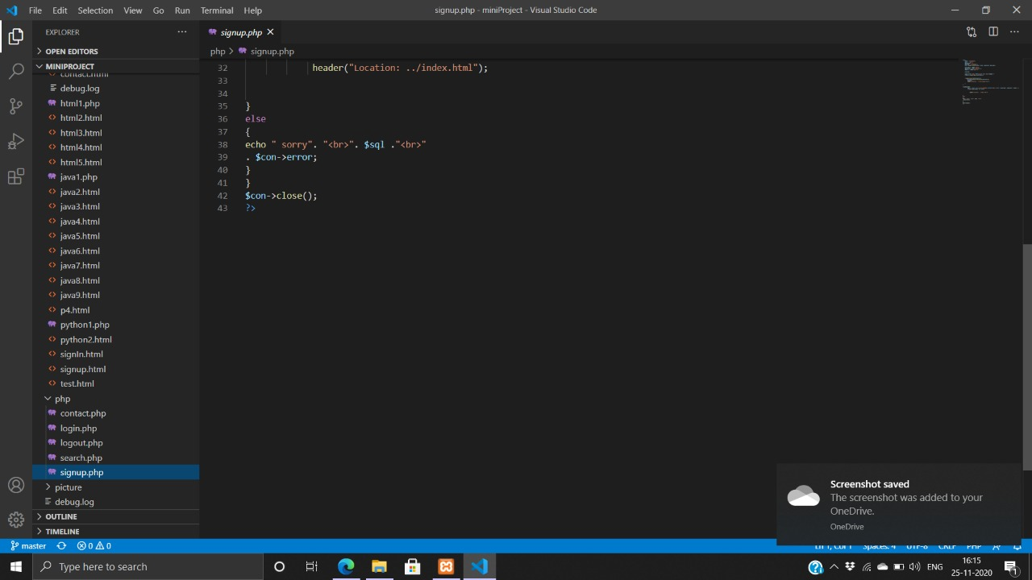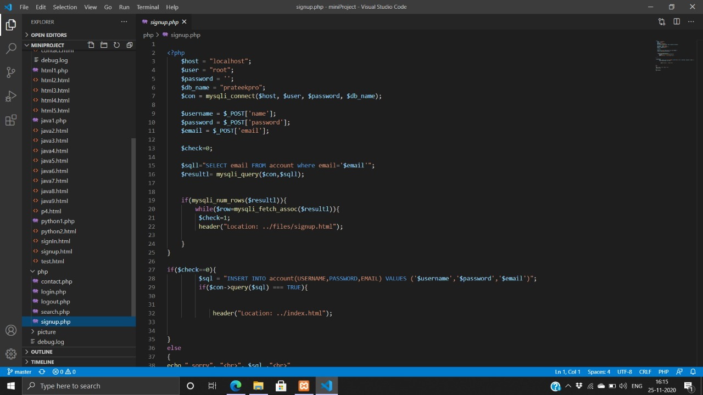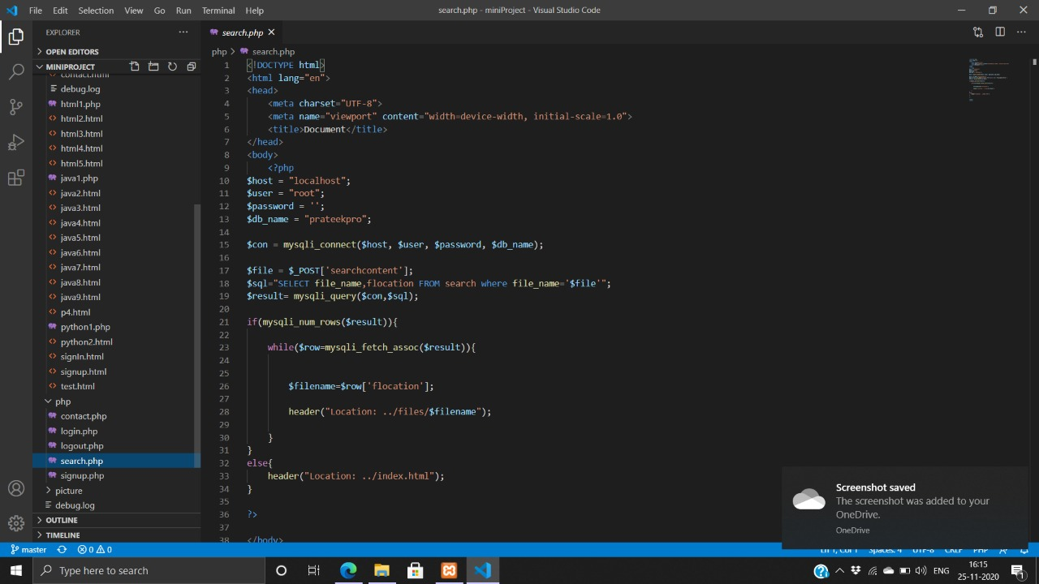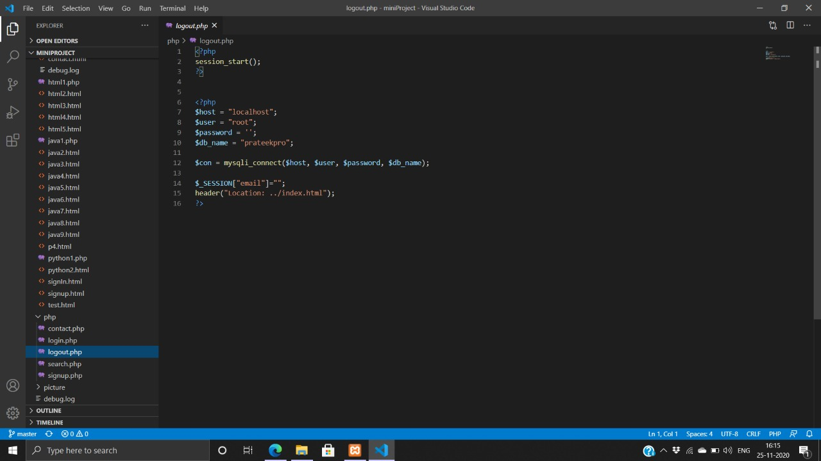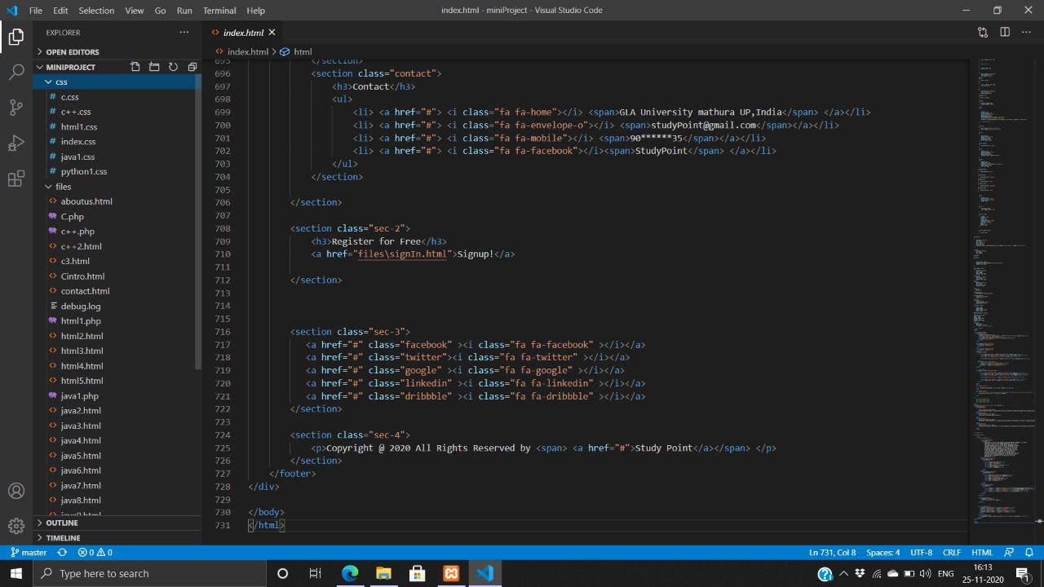

**How the Back-End Look Like:-**

**Back-End Code:-**

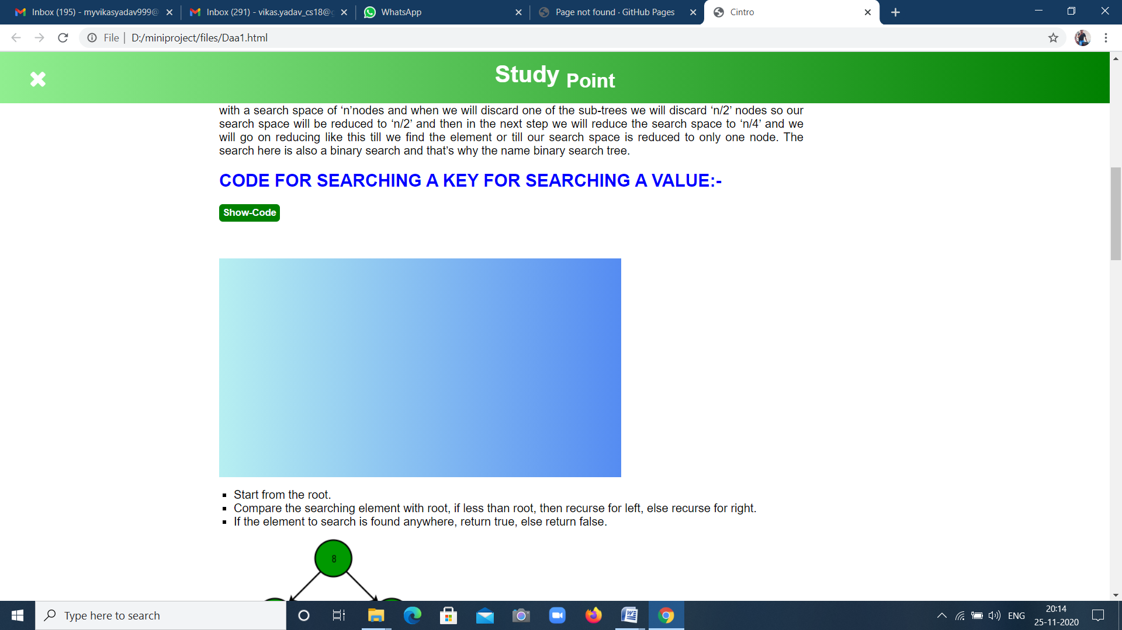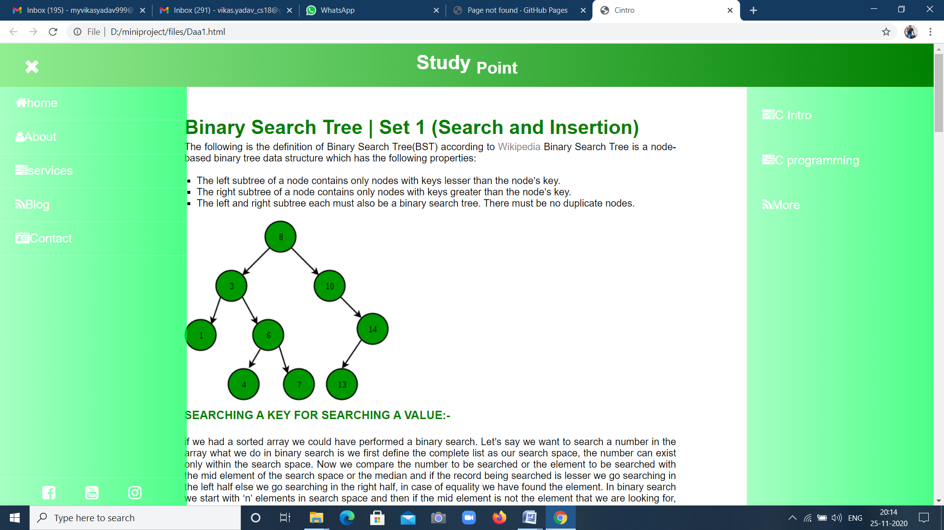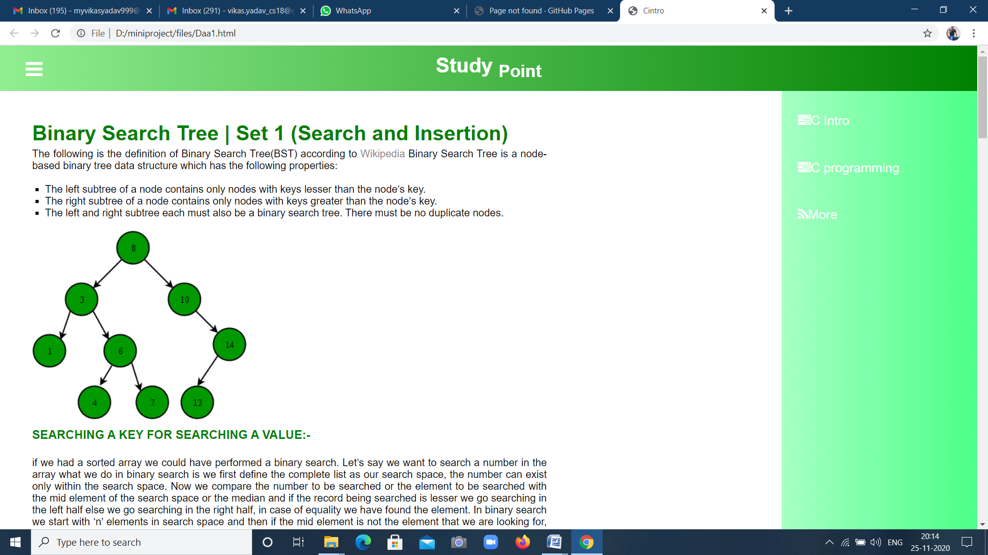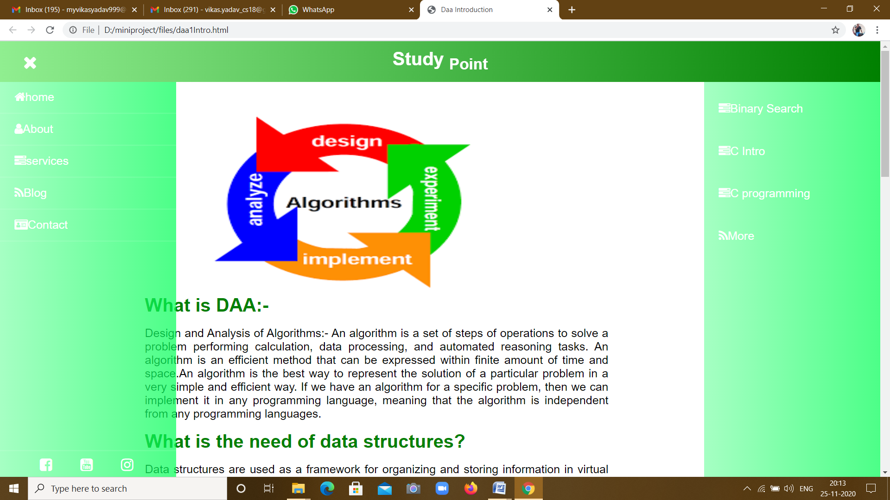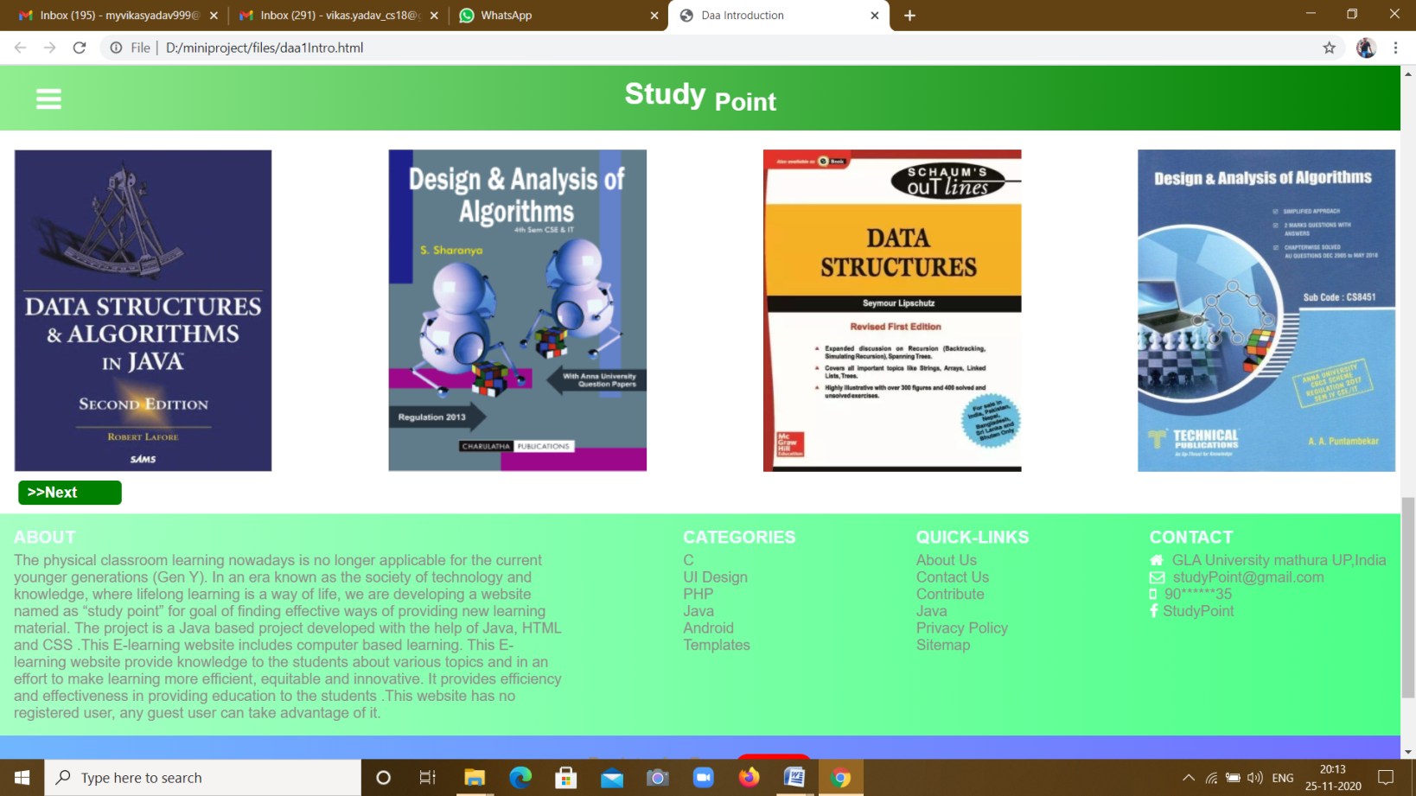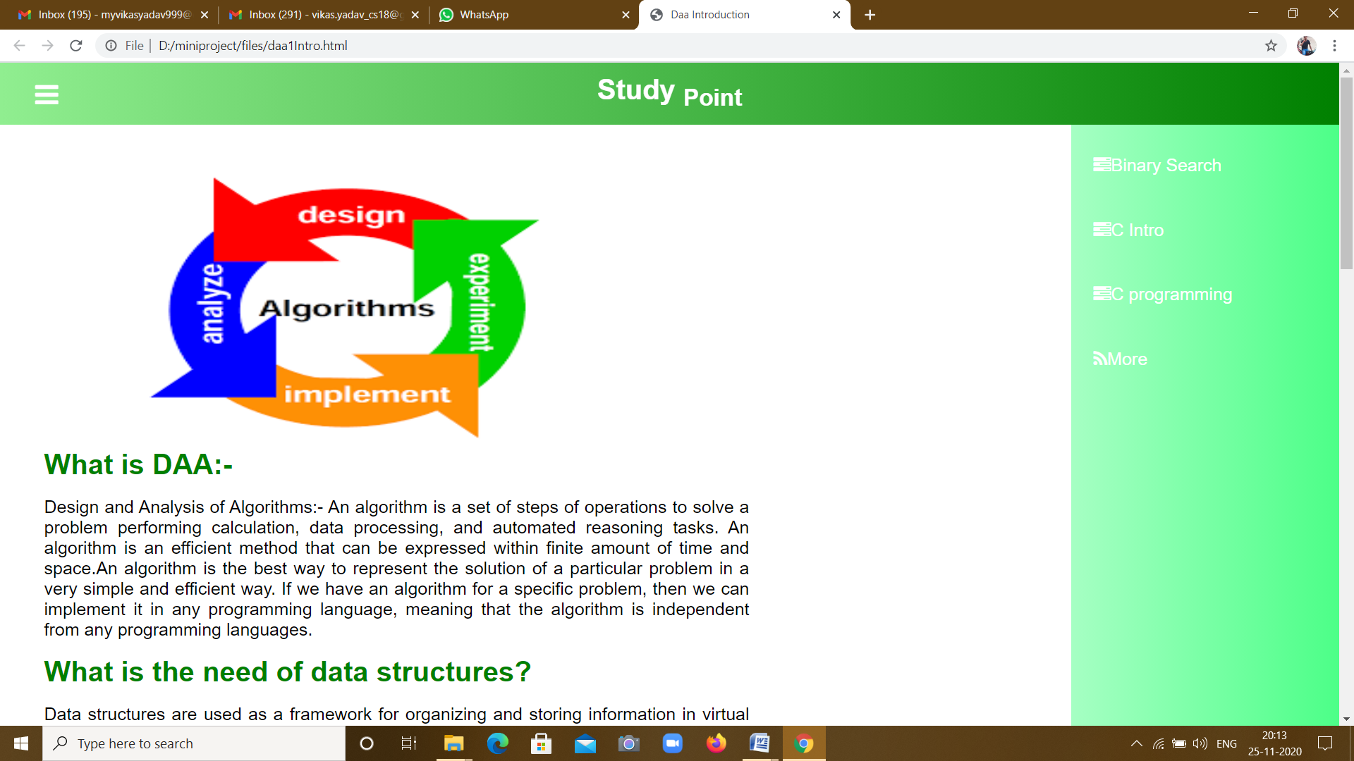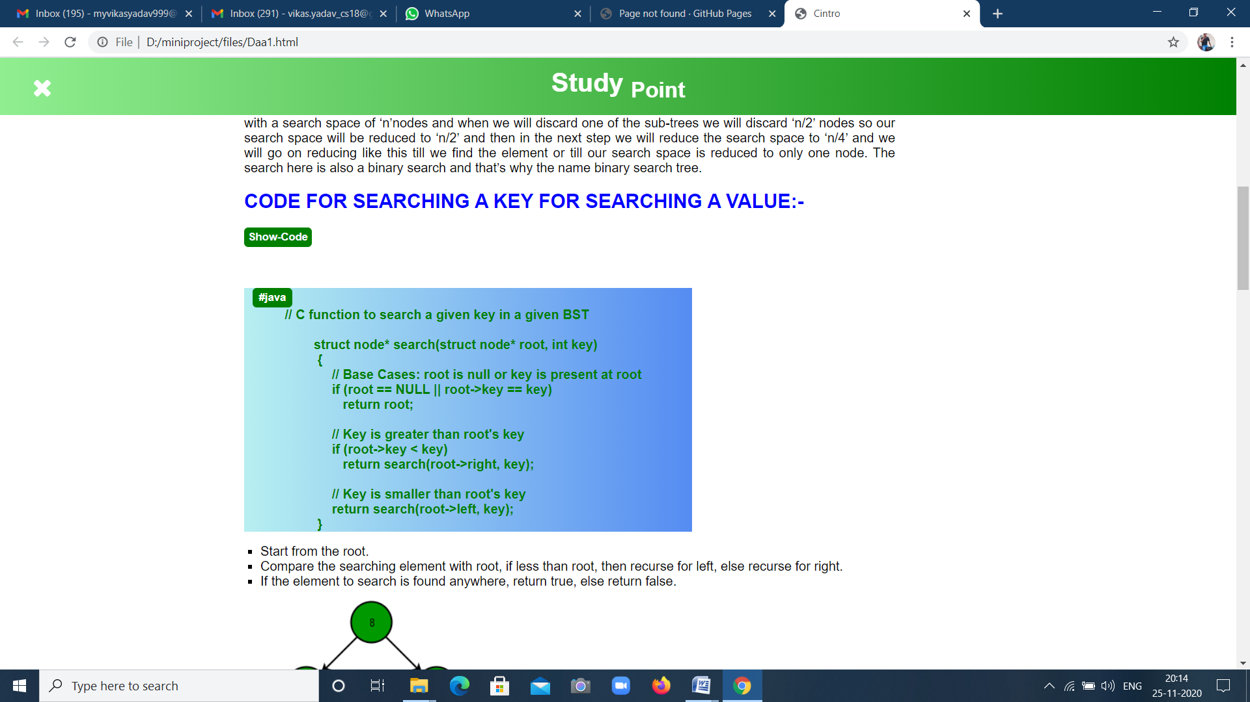

**How the Front-End Is Look Like:-**

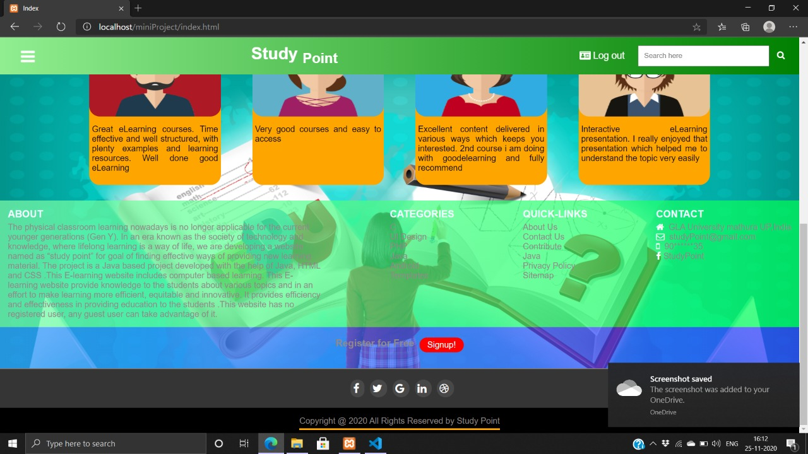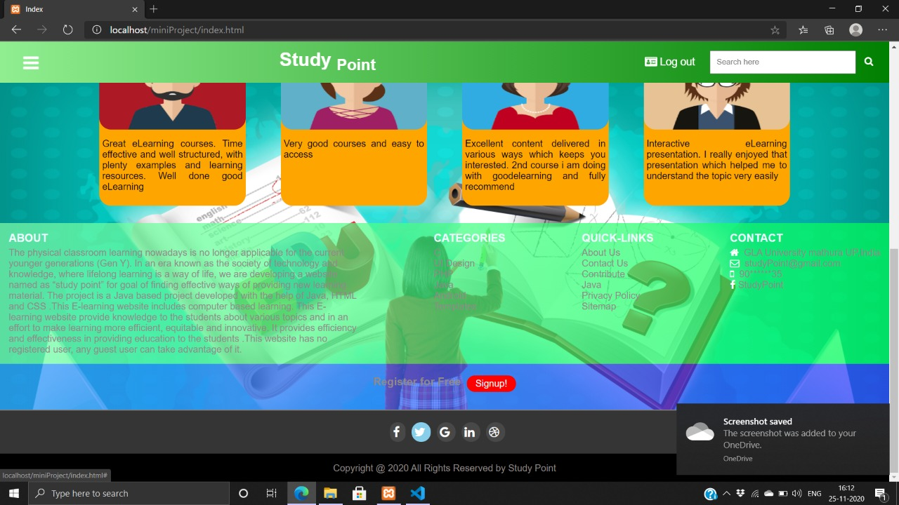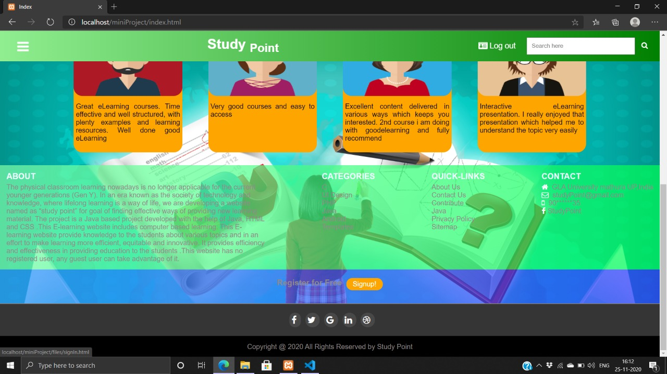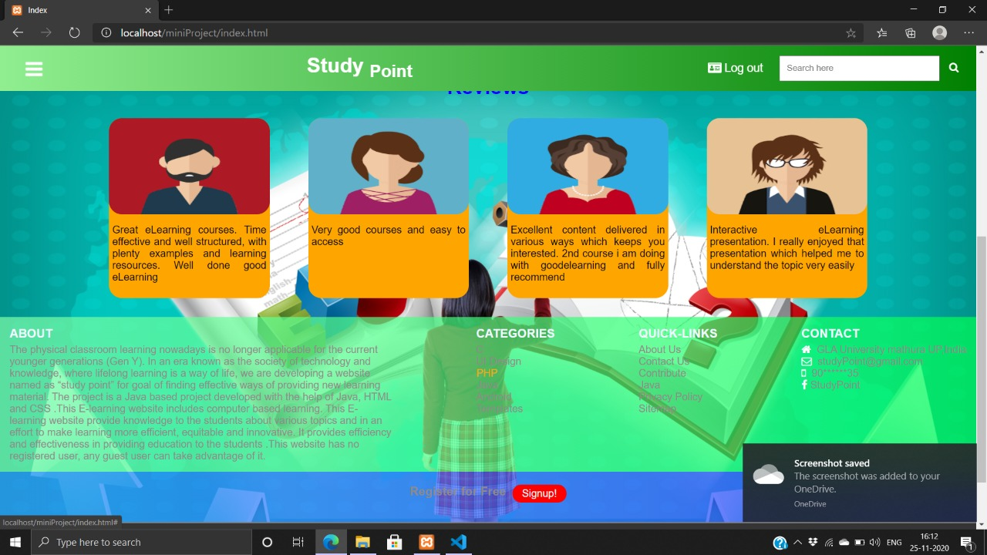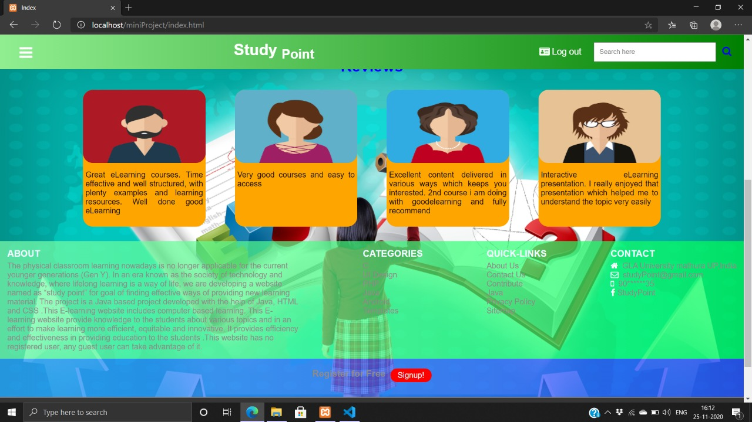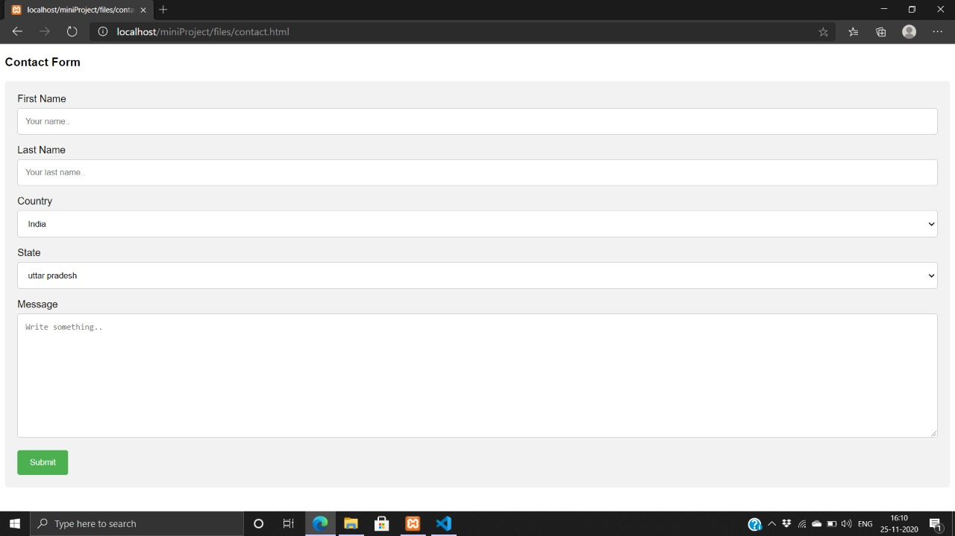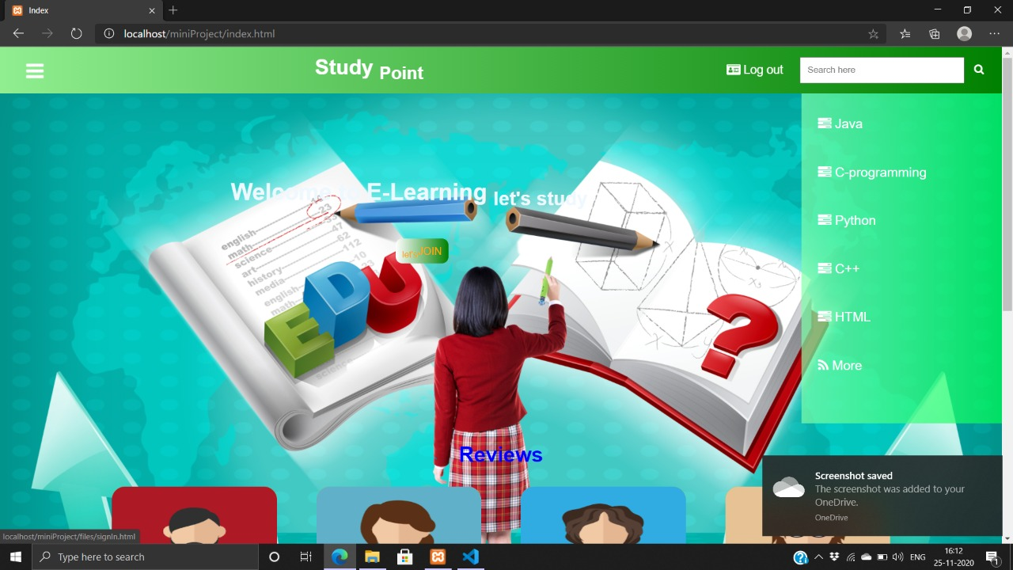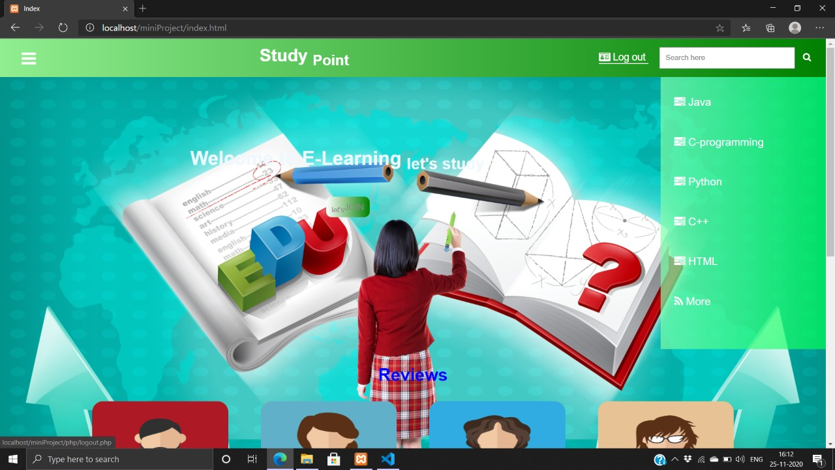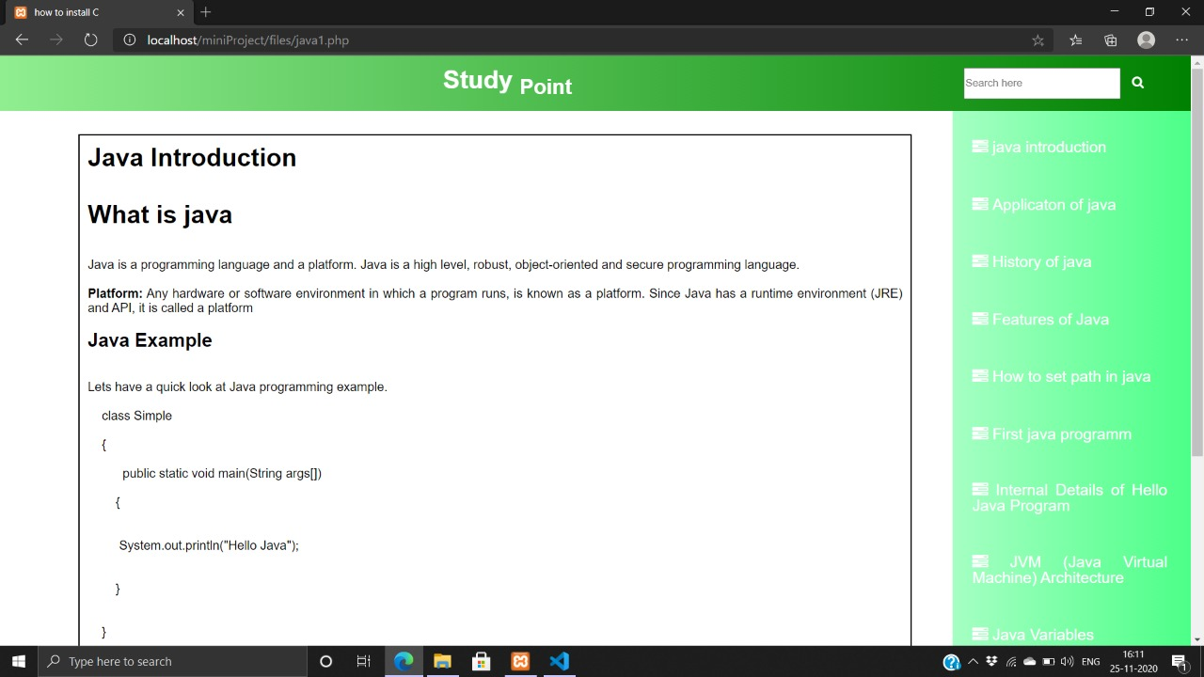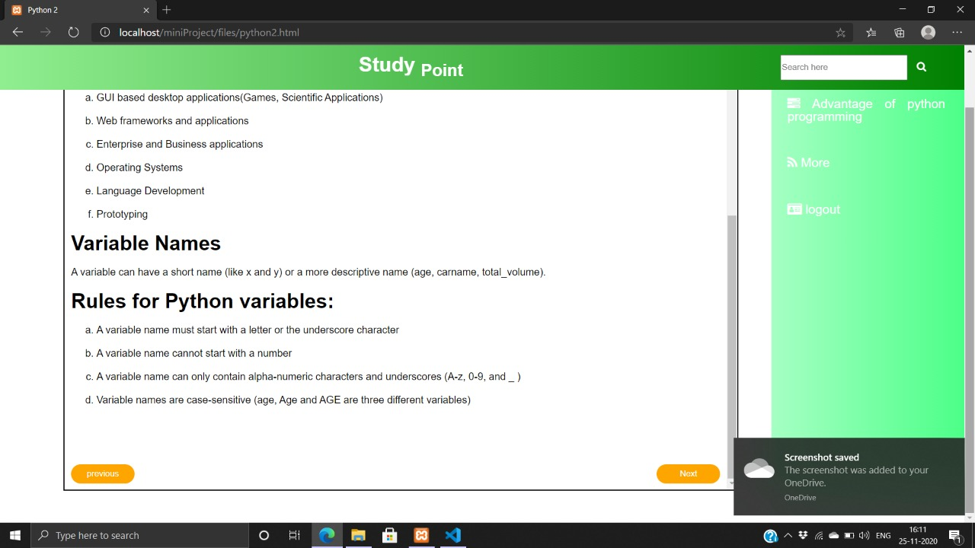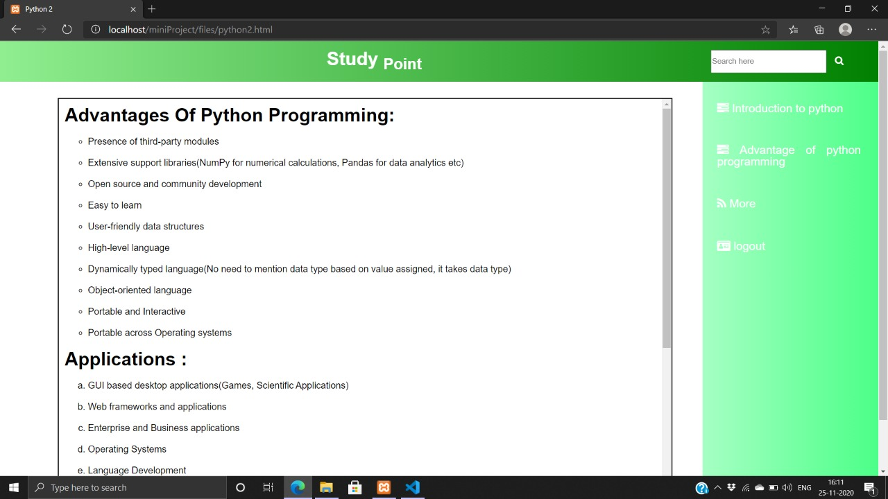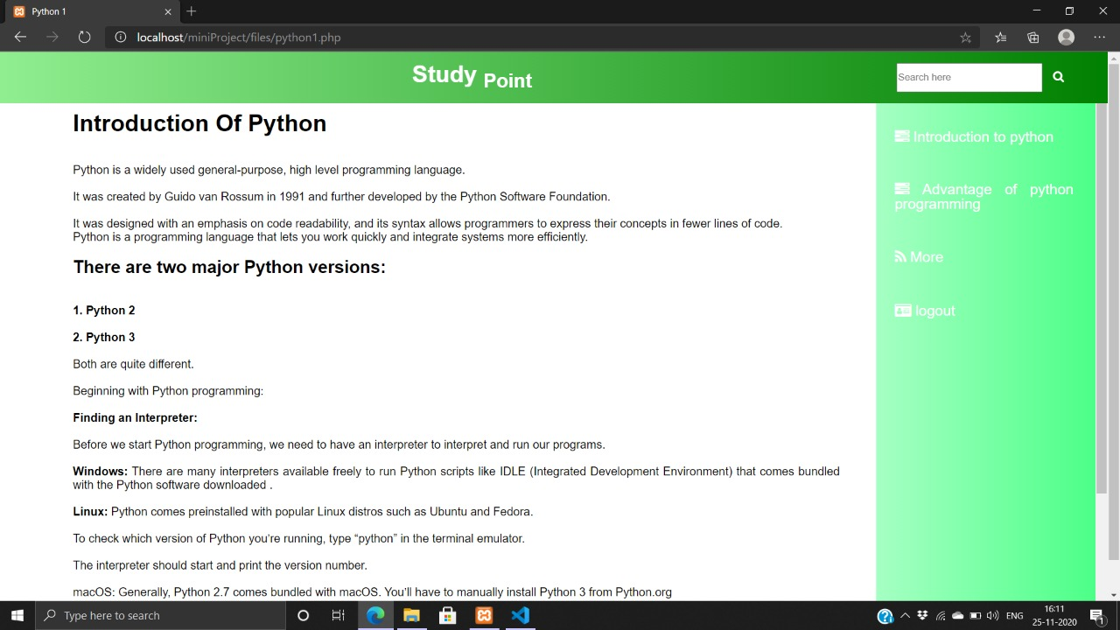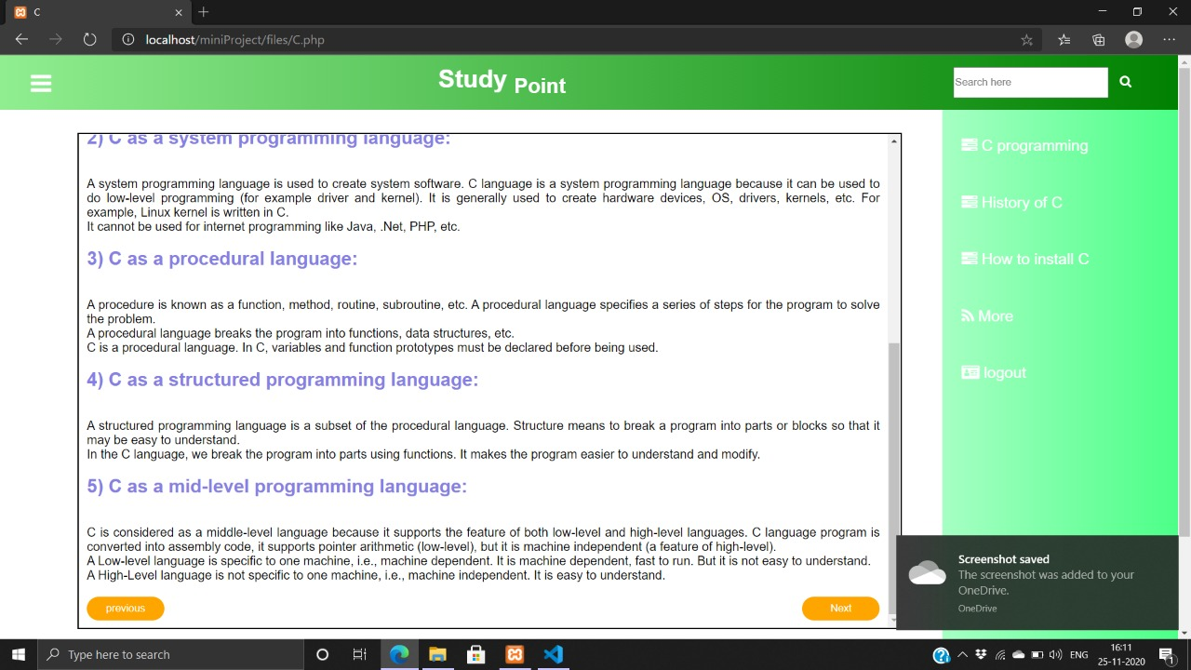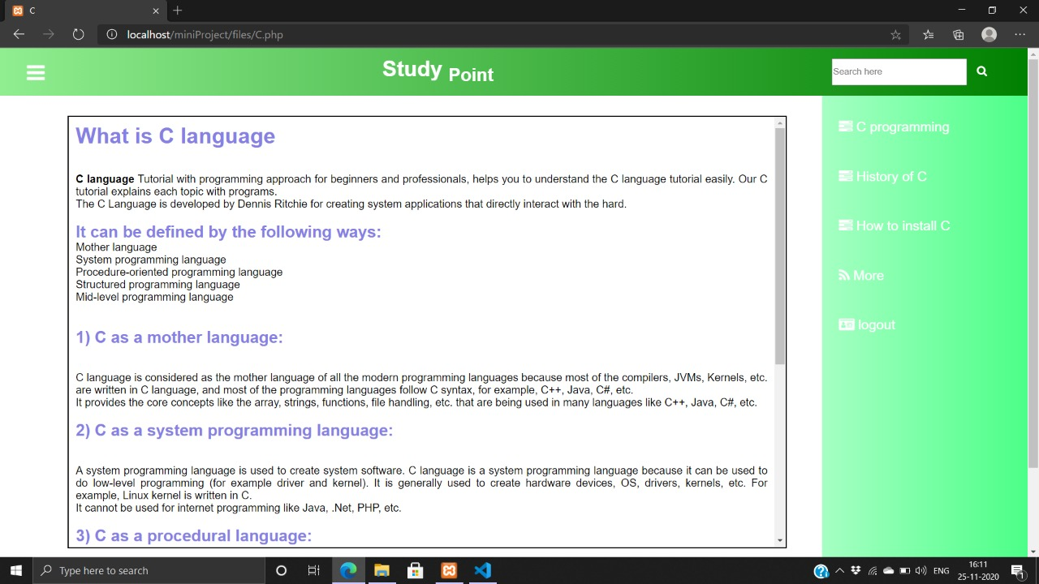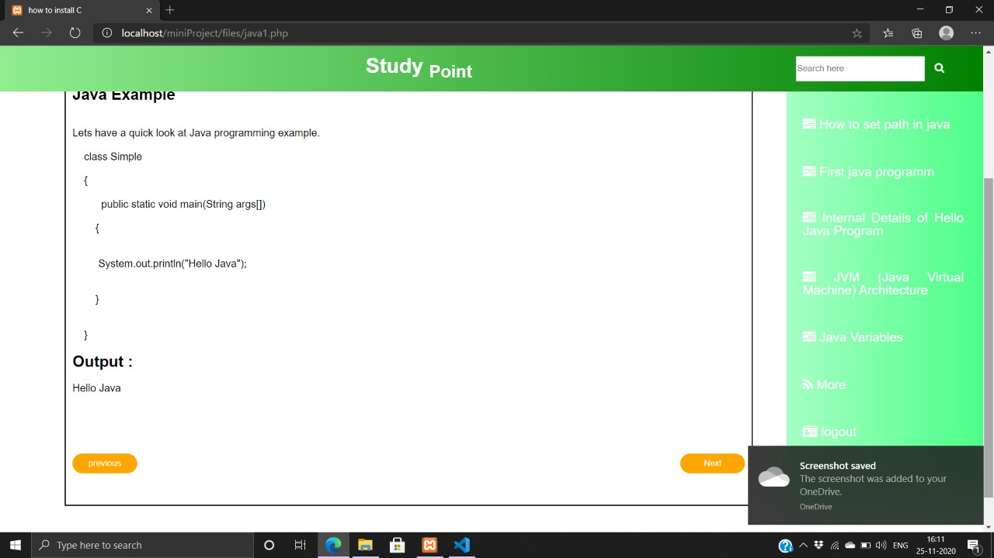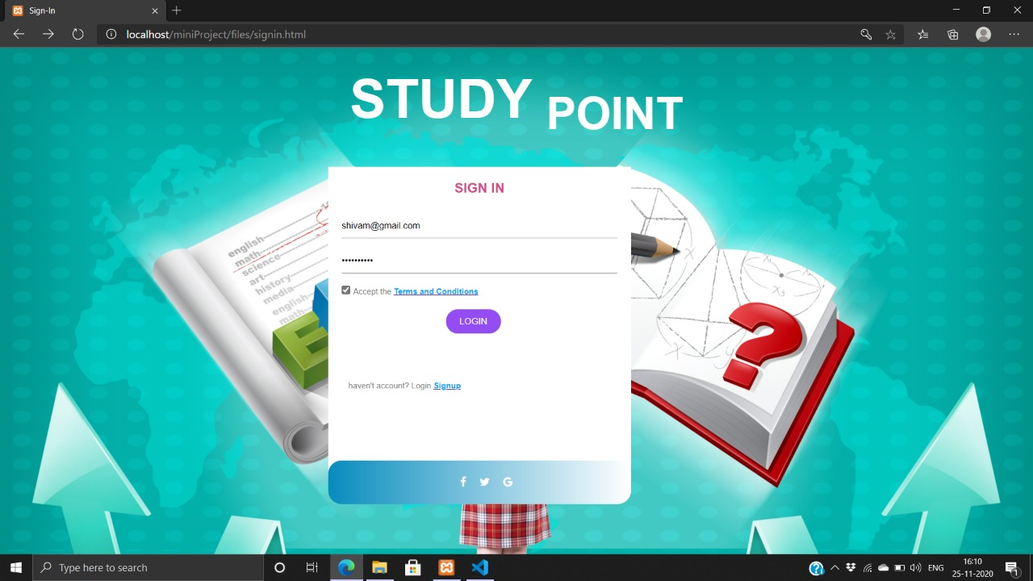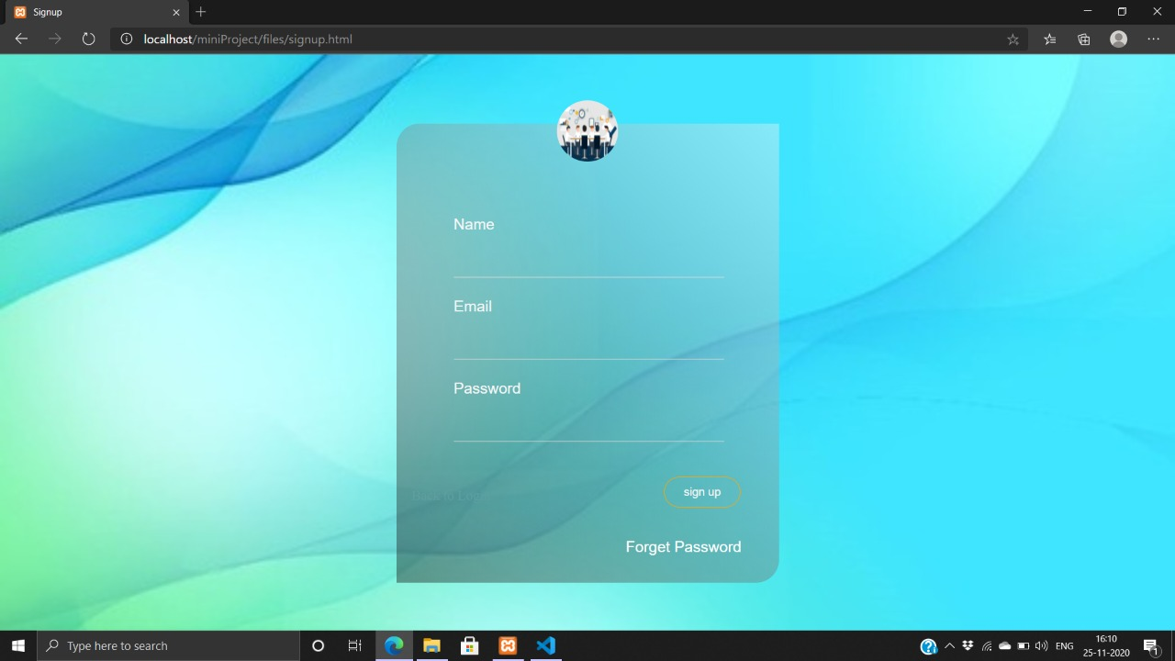

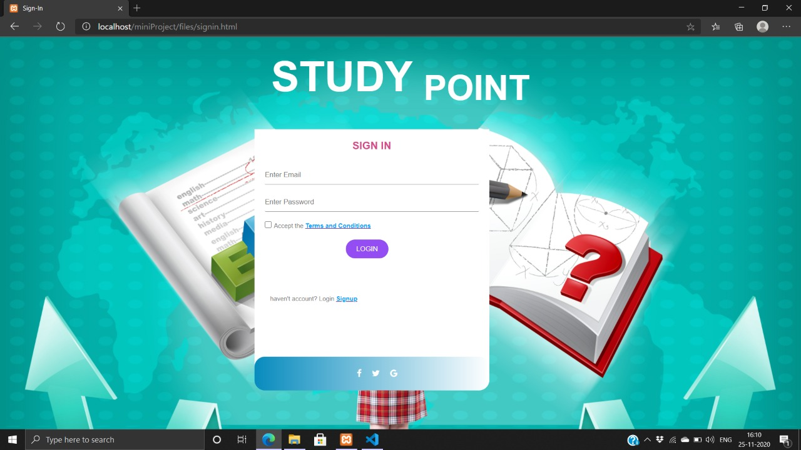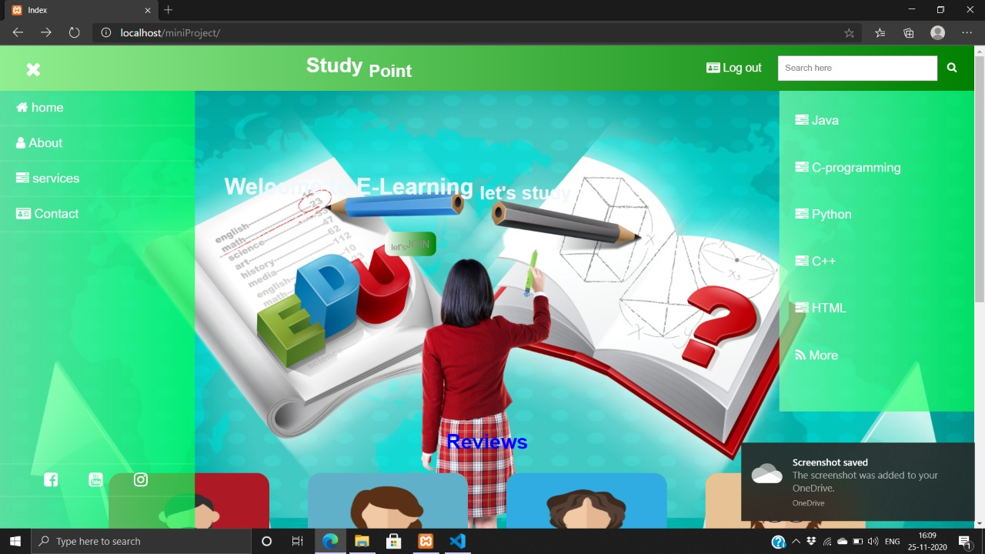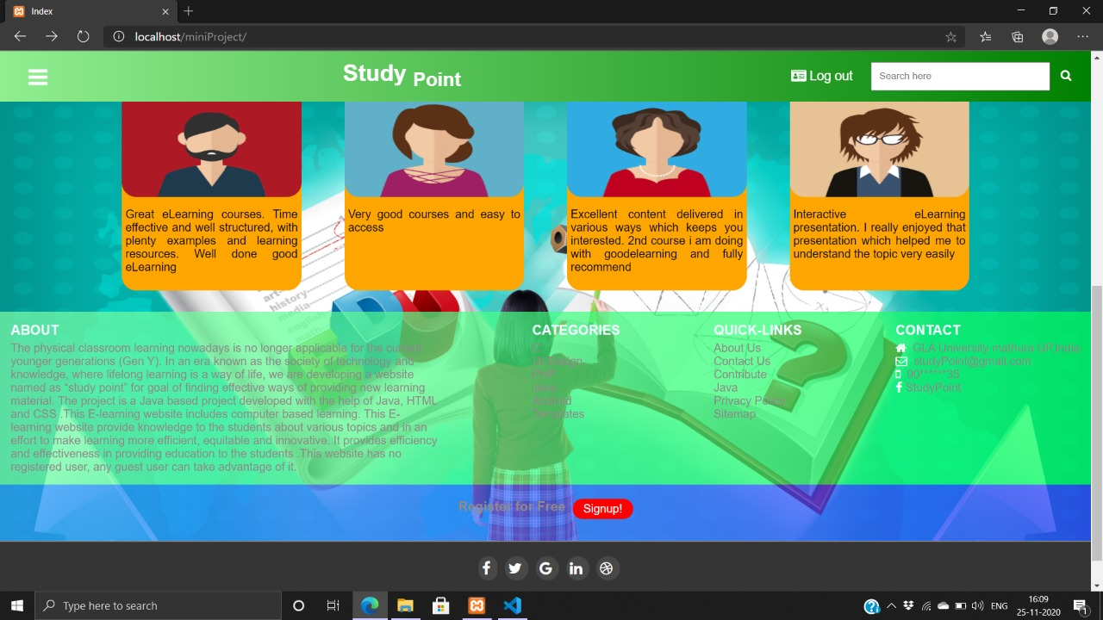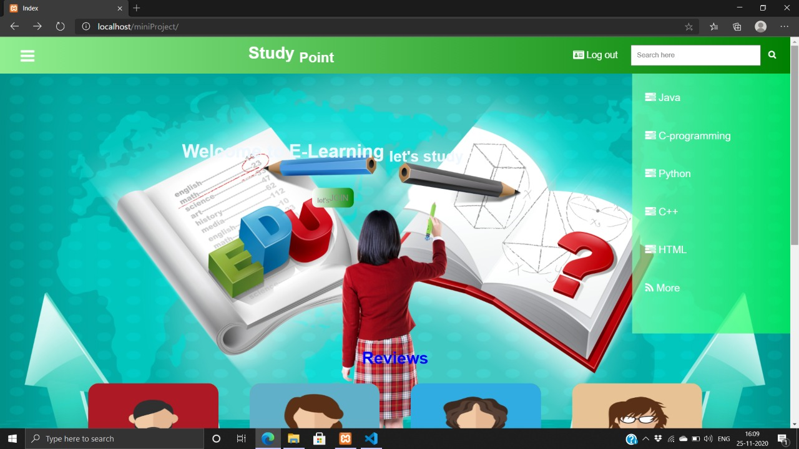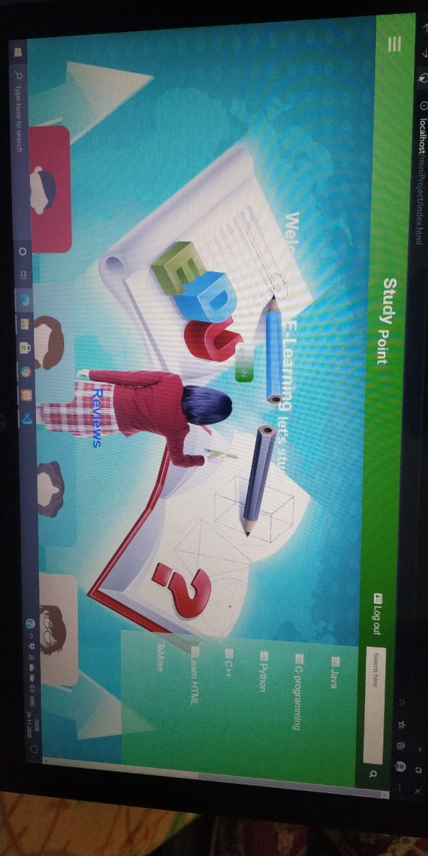

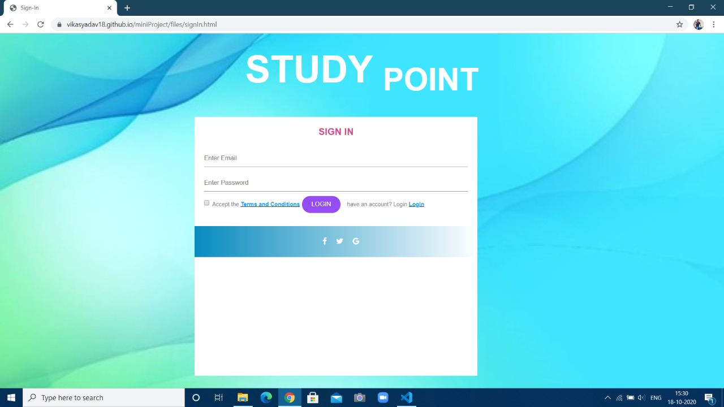

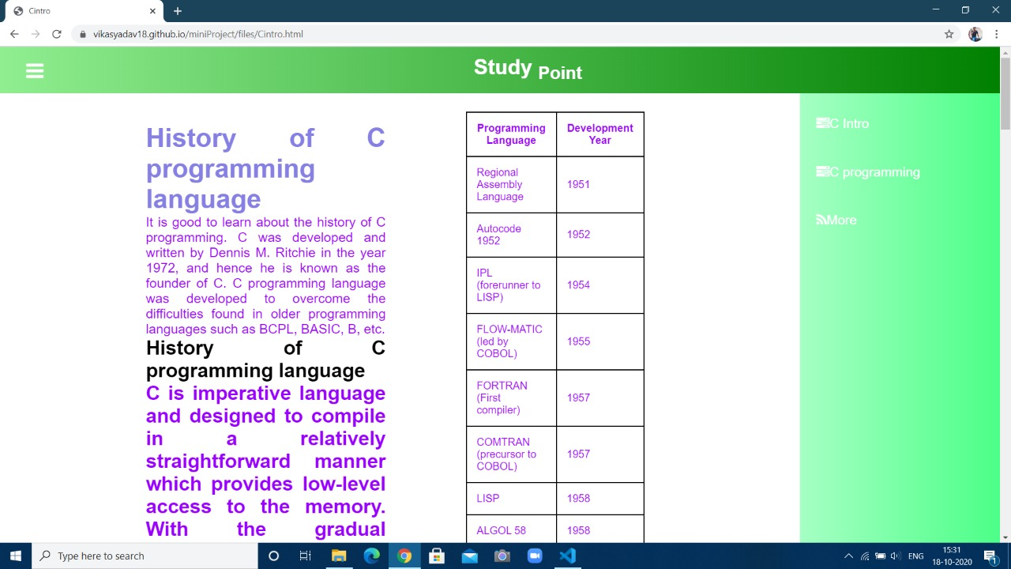

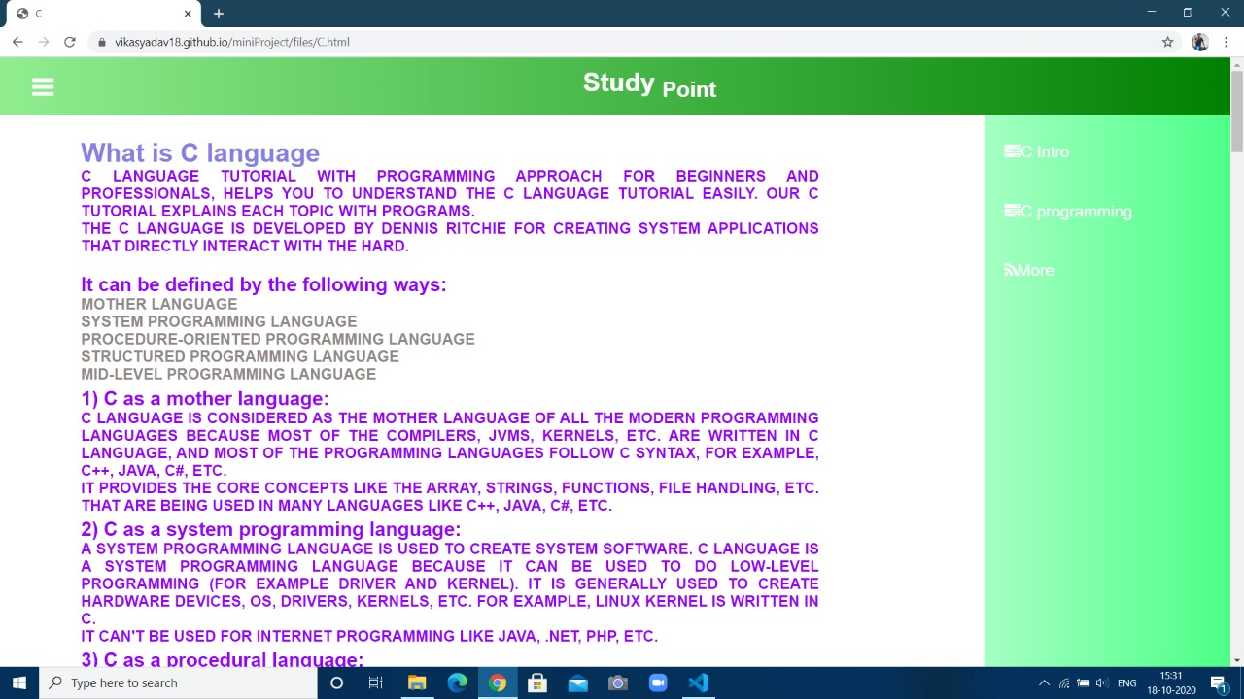

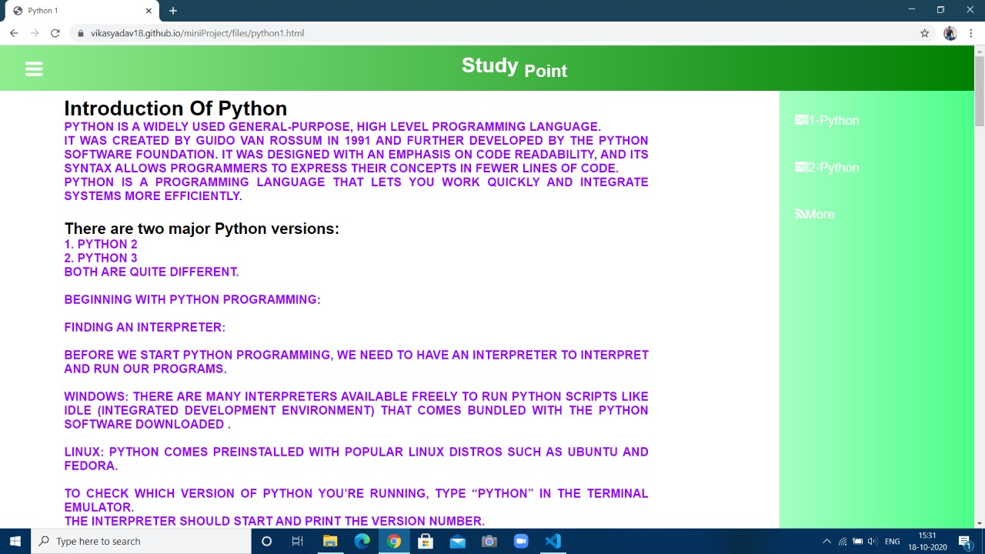

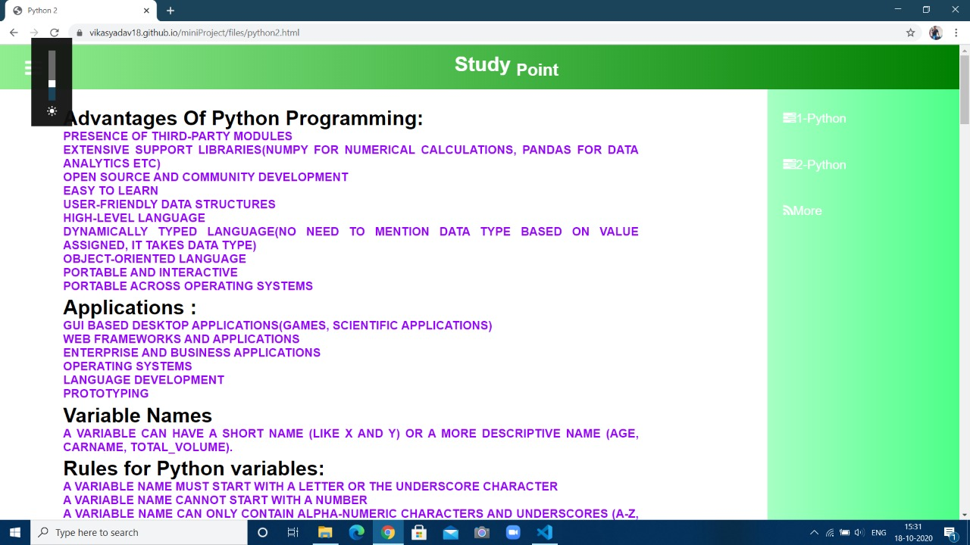

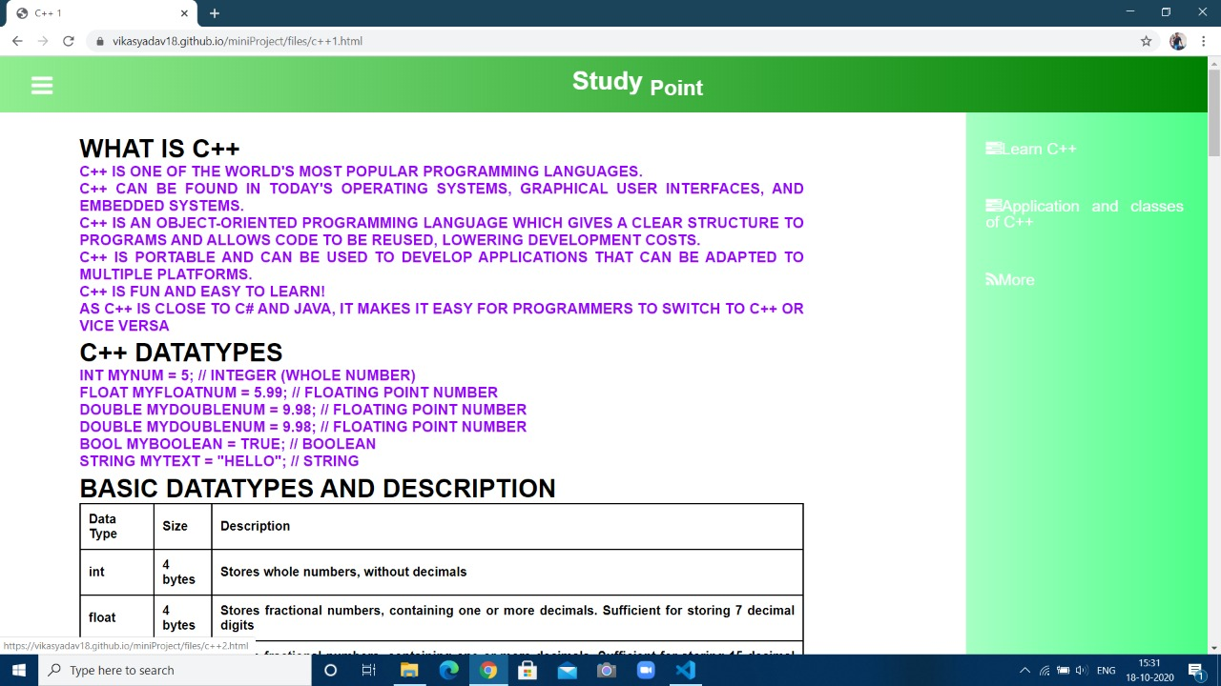

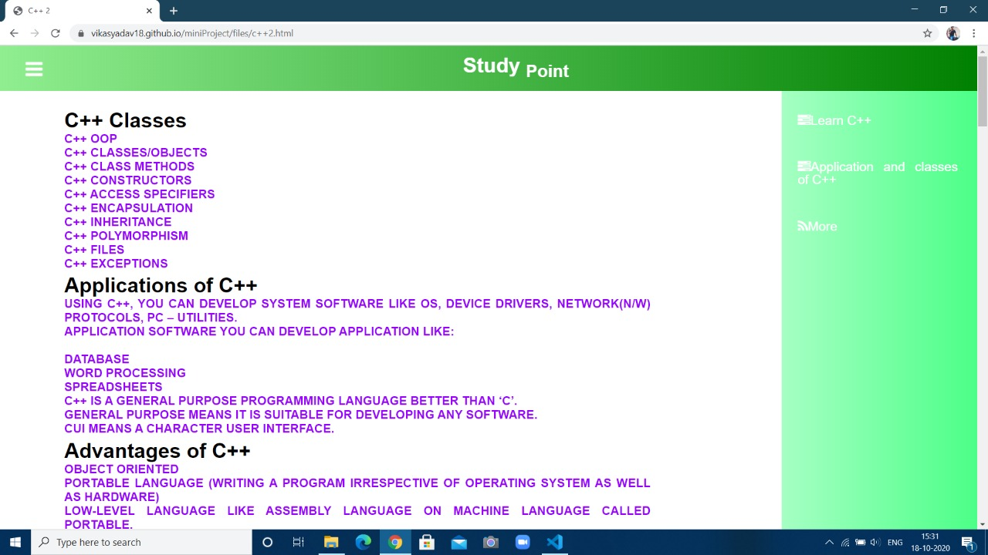

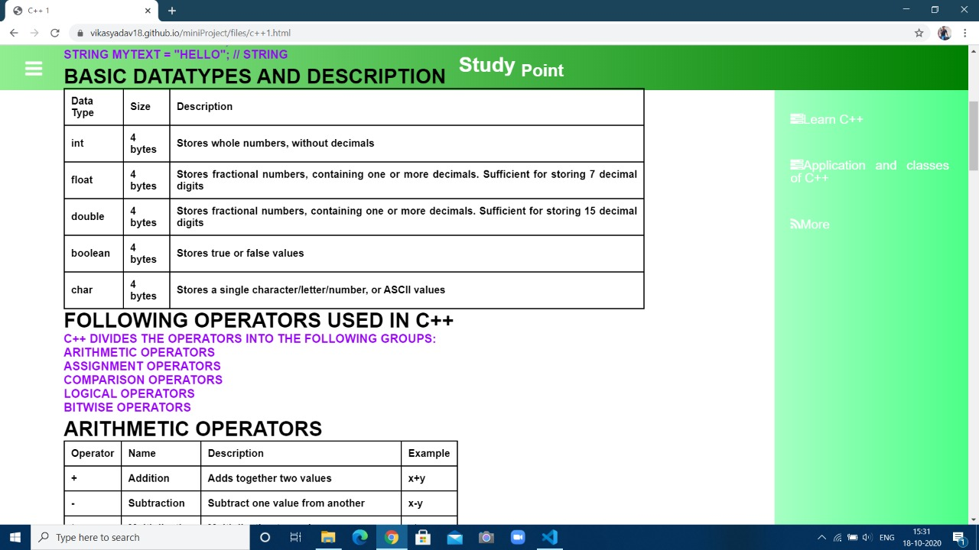

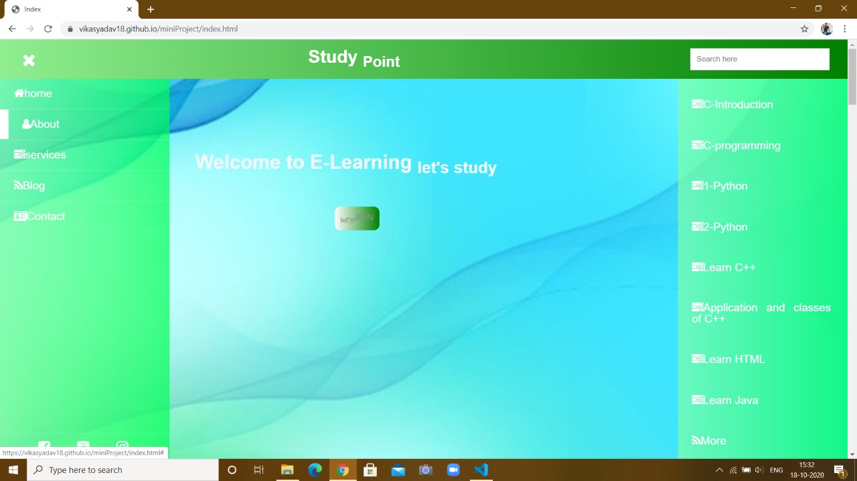

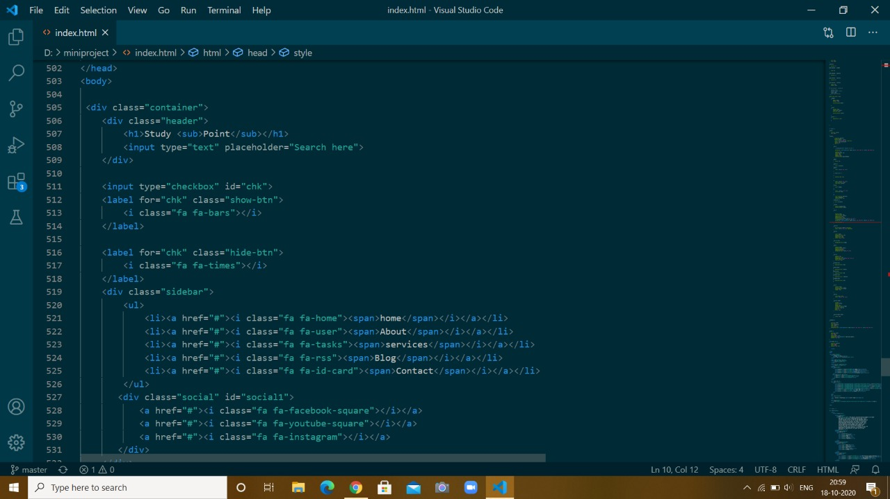

**Front-End Code:-**

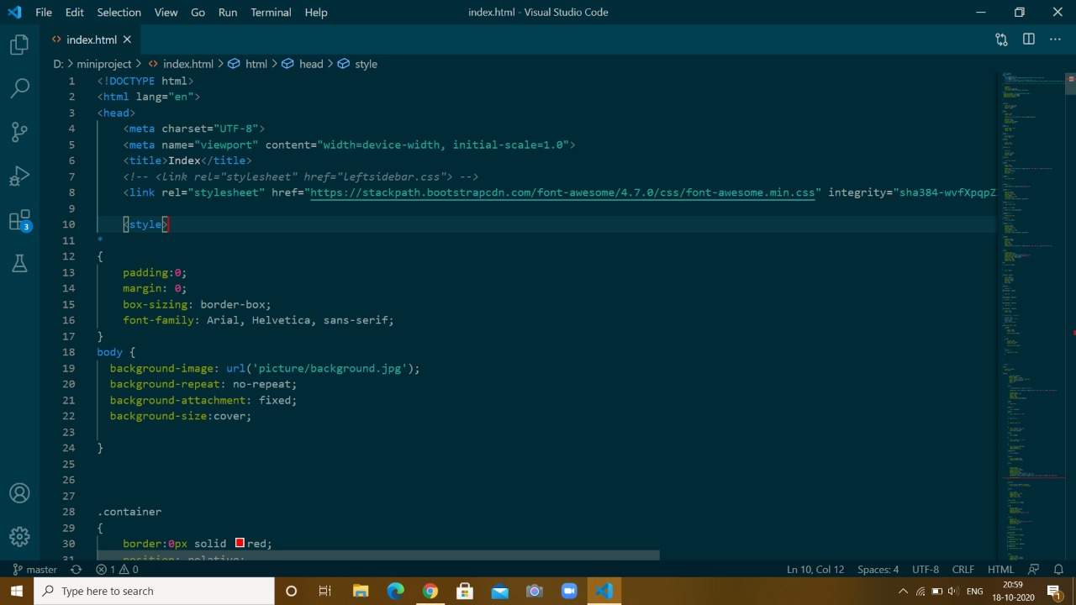

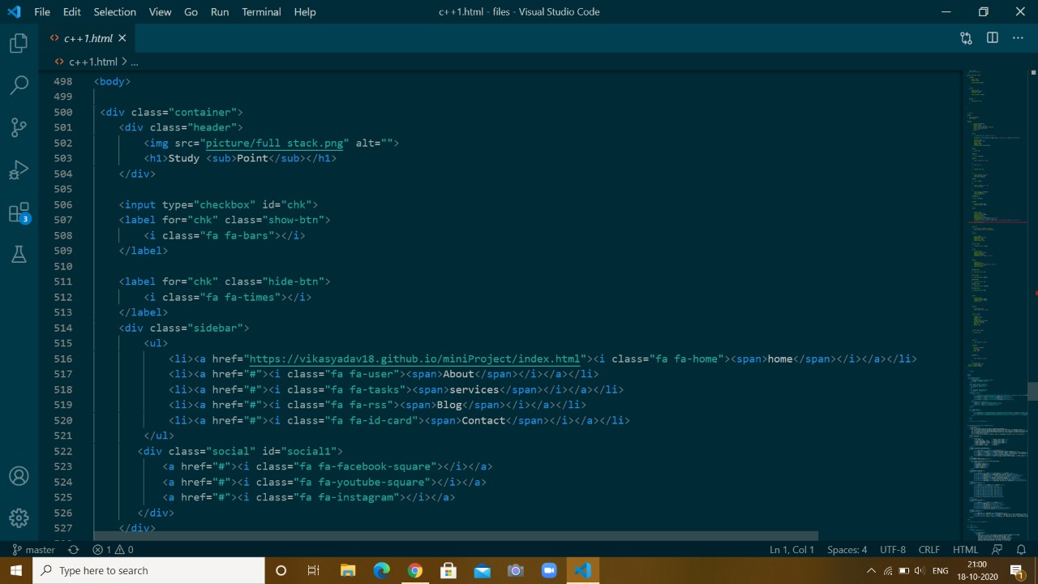

**Project Planning**

**References**

* [**https://www.javatpoint.com/**](https://www.javatpoint.com/)
* [**https://www.w3schools.com/html/**](https://www.w3schools.com/html/)
* **Udemy Online Course**